TRINITY LUTHERAN CHURCH
304 E. Ferris St., Galesburg, IL 61401
“the welcome place”

Fifth Sunday in Lent
March 28 & 29, 2020

+ + + GATHERING + + +

Prelude

Welcome and Friendship Registry
Invocation
Blessed be the holy Trinity, ☩ one God, who is present, who gives life, who calls into existence the things that do not exist.
Amen.

(Stand)
Confession & Forgiveness
If you were to keep watch over sins, O Lord, who could stand?
Yet with you is forgiveness, and so we confess.
Silence is kept for reflection.
Gracious God,
have mercy on us.
We confess that we have turned away from you, knowingly and unknowingly.
We have wandered from your resurrection life.
We have strayed from your love for all people.
Turn us back to you, O God.
Give us new hearts and right spirits, that we may find what is pleasing to you
and dwell in your house forever. Amen.
Receive good news: God turns to you in love.
“I will put my spirit in you, and you shall live,” says our God.
All your sin is forgiven in the name of ☩ Jesus Christ, who is the free and abounding gift of God’s grace for you.
Amen.

Gathering Song #886 ……..…. “O for a Thousand Tongues to Sing”

Greeting
The grace of our Lord Jesus Christ, the love of God,
and the communion of the Holy Spirit be with you all.
And also, with you.

Kyrie

The Cantor sings one verse in Greek, then the congregation sings three verses in English. Please take notice of the numbering of the verses.
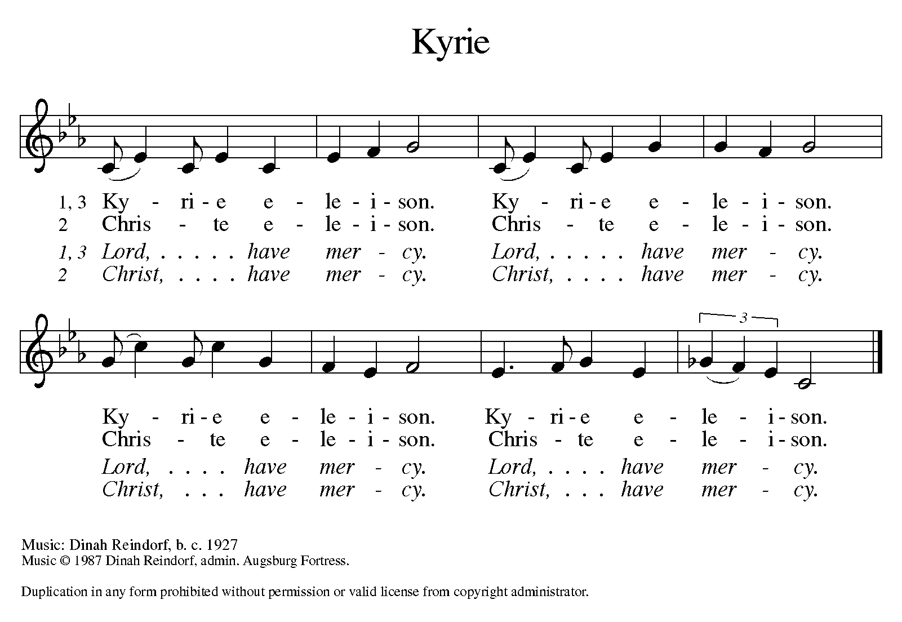
The Lord be with you
And also with you

Prayer of the Day
Almighty God, your Son came into the world to free us all from sin and death. Breathe upon us the power of your Spirit, that we may be raised to new life in Christ and serve you in righteousness all our days, through Jesus Christ, our Savior and Lord, who lives and reigns with you and the Holy Spirit, one God, now and forever.
Amen.

(Sit)
Children’s Message

+ + + WORD + + +

First Reading: Ezekiel 37:1-14
¹The hand of the Lord came upon me, and he brought me out by the spirit of the Lord and set me down in the middle of a valley; it was full of bones. ²He led me all around them; there were very many lying in the valley, and they were very dry. ³He said to me, “Mortal, can these bones live?” I answered, “O Lord God, you know.” ⁴Then he said to me, “Prophesy to these bones, and say to them: O dry bones, hear the word of the Lord. ⁵Thus says the Lord God to these bones: I will cause breath to enter you, and you shall live. ⁶I will lay sinews on you, and will cause flesh to come upon you, and cover you with skin, and put breath in you, and you shall live; and you shall know that I am the Lord.”
⁷So I prophesied as I had been commanded; and as I prophesied, suddenly there was a noise, a rattling, and the bones came together, bone to its bone. ⁸I looked, and there were sinews on them, and flesh had come upon them, and skin had covered them; but there was no breath in them. ⁹Then he said to me, “Prophesy to the breath, prophesy, mortal, and say to the breath: Thus says the Lord God: Come from the four winds, O breath, and breathe upon these slain, that they may live.” ¹⁰I prophesied as he commanded me, and the breath came into them, and they lived, and stood on their feet, a vast multitude.
¹¹Then he said to me, “Mortal, these bones are the whole house of Israel. They say, ‘Our bones are dried up, and our hope is lost; we are cut off completely.’ ¹²Therefore prophesy, and say to them, Thus says the Lord God: I am going to open your graves, and bring you up from your graves, O my people; and I will bring you back to the land of Israel. ¹³And you shall know that I am the Lord, when I open your graves, and bring you up from your graves, O my people. ¹⁴I will put my spirit within you, and you shall live, and I will place you on your own soil; then you shall know that I, the Lord, have spoken and will act, says the Lord.”
The word of God.
Thanks be to God.

Psalm: Psalm 130

All read responsively by whole verse, beginning with the cantor.

¹Out | of the depths
I cry to | you, O Lord;
²O Lord, | hear my voice!
Let your ears be attentive to the voice of my | supplication.
³If you were to keep watch | over sins,
O Lord, | who could stand?
⁴Yet with you | is forgiveness,
in order that you | may be feared.
⁵I wait for you, O Lord; | my soul waits;
in your word | is my hope.
⁶My soul waits for the Lord more than those who keep watch | for the morning,
more than those who keep watch | for the morning.
⁷O Israel, wait for the Lord, for with the Lord there is | steadfast love;
with the Lord there is plen- | teous redemption.
⁸For the Lord shall | redeem Israel
from | all their sins.

Second Reading: Romans 8:6-11

⁶To set the mind on the flesh is death, but to set the mind on the Spirit is life and peace. ⁷For this reason the mind that is set on the flesh is hostile to God; it does not submit to God’s law—indeed it cannot, ⁸and those who are in the flesh cannot please God.
⁹But you are not in the flesh; you are in the Spirit, since the Spirit of God dwells in you. Anyone who does not have the Spirit of Christ does not belong to him. ¹⁰But if Christ is in you, though the body is dead because of sin, the Spirit is life because of righteousness. ¹¹If the Spirit of him who raised Jesus from the dead dwells in you, he who raised Christ from the dead will give life to your mortal bodies also through his Spirit that dwells in you.

The word of God.
Thanks be to God.

(Stand)
Gospel Acclamation p. 142

Gospel Reading: John 11” 1-45
Now a certain man was ill, Lazarus of Bethany, the village of Mary and her sister Martha. ² Mary was the one who anointed the Lord with perfume and wiped his feet with her hair; her brother Lazarus was ill. ³ So the sisters sent a message to Jesus, “Lord, he whom you love is ill.” ⁴ But when Jesus heard it, he said, “This illness does not lead to death; rather it is for God’s glory, so that the Son of God may be glorified through it.” ⁵ Accordingly, though Jesus loved Martha and her sister and Lazarus, ⁶ after having heard that Lazarus was ill, he stayed two days longer in the place where he was.
⁷ Then after this he said to the disciples, “Let us go to Judea again.” ⁸ The disciples said to him, “Rabbi, the Jews were just now trying to stone you, and are you going there again?” ⁹ Jesus answered, “Are there not twelve hours of daylight? Those who walk during the day do not stumble, because they see the light of this world. ¹⁰ But those who walk at night stumble, because the light is not in them.” ¹¹ After saying this, he told them, “Our friend Lazarus has fallen asleep, but I am going there to awaken him.” ¹² The disciples said to him, “Lord, if he has fallen asleep, he will be all right.” ¹³ Jesus, however, had been speaking about his death, but they thought that he was referring merely to sleep. ¹⁴ Then Jesus told them plainly, “Lazarus is dead. ¹⁵ For your sake I am glad I was not there, so that you may believe. But let us go to him.” ¹⁶ Thomas, who was called the Twin, said to his fellow disciples, “Let us also go, that we may die with him.”
¹⁷ When Jesus arrived, he found that Lazarus had already been in the tomb four days. ¹⁸ Now Bethany was near Jerusalem, some two miles away, ¹⁹ and many of the Jews had come to Martha and Mary to console them about their brother. ²⁰ When Martha heard that Jesus was coming, she went and met him, while Mary stayed at home. ²¹ Martha said to Jesus, “Lord, if you had been here, my brother would not have died. ²² But even now I know that God will give you whatever you ask of him.” ²³ Jesus said to her, “Your brother will rise again.” ²⁴ Martha said to him, “I know that he will rise again in the resurrection on the last day.” ²⁵ Jesus said to her, “I am the resurrection and the life. Those who believe in me, even though they die, will live, ²⁶ and everyone who lives and believes in me will never die. Do you believe this?” ²⁷ She said to him, “Yes, Lord, I believe that you are the Messiah, the Son of God, the one coming into the world.”
²⁸ When she had said this, she went back and called her sister Mary, and told her privately, “The Teacher is here and is calling for you.” ²⁹ And when she heard it, she got up quickly and went to him. ³⁰ Now Jesus had not yet come to the village, but was still at the place where Martha had met him. ³¹ The Jews who were with her in the house, consoling her, saw Mary get up quickly and go out. They followed her because they thought that she was going to the tomb to weep there. ³² When Mary came where Jesus was and saw him, she knelt at his feet and said to him, “Lord, if you had been here, my brother would not have died.” ³³ When Jesus saw her weeping, and the Jews who came with her also weeping, he was greatly disturbed in spirit and deeply moved. ³⁴ He said, “Where have you laid him?” They said to him, “Lord, come and see.” ³⁵ Jesus began to weep. ³⁶ So the Jews said, “See how he loved him!” ³⁷ But some of them said, “Could not he who opened the eyes of the blind man have kept this man from dying?”
³⁸ Then Jesus, again greatly disturbed, came to the tomb. It was a cave, and a stone was lying against it. ³⁹ Jesus said, “Take away the stone.” Martha, the sister of the dead man, said to him, “Lord, already there is a stench because he has been dead four days.” ⁴⁰ Jesus said to her, “Did I not tell you that if you believed, you would see the glory of God?” ⁴¹ So they took away the stone. And Jesus looked upward and said, “Father, I thank you for having heard me. ⁴² I knew that you always hear me, but I have said this for the sake of the crowd standing here, so that they may believe that you sent me.” ⁴³ When he had said this, he cried with a loud voice, “Lazarus, come out!” ⁴⁴ The dead man came out, his hands and feet bound with strips of cloth, and his face wrapped in a cloth. Jesus said to them, “Unbind him, and let him go.”
⁴⁵ Many of the Jews therefore, who had come with Mary and had seen what Jesus did, believed in him.
The gospel of the Lord.
Congregation: Praise to you, O Christ.

(Sit)
Sermon ………………….….………...…...…….… Pastor Carrie Carnes

(Stand)
Hymn of the Day #379 “Now the Green Blade Rises”

Apostles’ Creed

I believe in God, the Father, Almighty, creator of heaven and earth.
I believe in Jesus Christ, God’s only Son, our Lord, who was conceived by the Holy Spirit, born of the virgin Mary, suffered under Pontius Pilate, was crucified, died, and was buried; he descended to the dead. On the third day he rose again; he ascended into heaven, he is seated at the right hand of the Father, and he will come to judge the living and the dead.
I believe in the Holy Spirit, the holy catholic church, the communion of saints, the forgiveness of sins, the resurrection of the body, and the life everlasting. Amen.

Offering

Offering Prayer
Holy and generous host, you set a table where we feast as friends. Prepare us to witness to your goodness with every gift you have given us to share, that all people may know your peace through Jesus Christ, now and forever
Amen.

Prayers of Intercession
Turning our hearts to God who is gracious and merciful, we pray for the church, the world, and all who are in need.
A brief silence.
God of life, bind your faithful people into one body. Enliven the church with your Spirit and bless the work of those who work for its renewal (like Hans Nielsen Hauge, whom we commemorate today). Accomplish your work of salvation in us and through us, for the sake of the world. Hear us, O God.
Your mercy is great.

God of life, you love the world you have made and you grieve when creation suffers. Restore polluted lands and waterways. Heal areas of the world ravaged by storms, floods, wildfires, droughts, or other natural disasters. Bring all things to new life. Hear us, O God.
Your mercy is great.

God of life, show redemption to all who watch and wait with eager expectation: those longing for wars to cease, those waiting for immigration paperwork to finalize, those seeking election, and those in dire need of humanitarian relief. Come quickly with your hope. Hear us, O God.
Your mercy is great.

God of life, you weep with those who grieve. Unbind all who are held captive by anxiety, despair, or pain (especially). Fill us with compassion and empathy for those who struggle, and keep us faithful in prayer. Hear us, O God.
Your mercy is great.

God of life, we give thanks for opportunities for this congregation to collaborate with our community in caring for the needs of our neighbors. (Particular ministry partnerships may be named.) Strengthen our ties with other local congregations, agencies, and services. Hear us, O God.
Your mercy is great.

Holy God, thank you for the powerful healing we witness through doctors and nurses, medication, therapy, and holistic means. Break through clouds of pain and anguish with your voice of comfort. Proclaim hope to all who grieve, and send healing to all who are sick especially Jane, Ian, Ken, Marcy, Charlotte, Bob, Rosie, Robb, Charles, Carolina, Sandy, Patti, Jon, Jan, Kim, Helen, Eric, CeCe, Larry, Thad, Lyle, Billie, Tom, Kirsten, Warren, Katherine, Gail and those we name silently or aloud….pause….. Give patience and compassion to those who provide care. Hear us, O God
Your mercy is great.

God of life, you are our resurrection. We remember all those who have died and trust that, in you, they will live again (especially). Breathe new life into our dry bones, that we, too, might live with you forever. Hear us, O God.
Your mercy is great.

Pastor Carnes - According to your steadfast love, O God, hear these and all our prayers as we commend them to you; through Christ our Lord.
Amen.

Lord’s Prayer
Let us pray with confidence in the words our Savior gave us:
Our Father in heaven, hallowed be your name, your kingdom come, your will be done, on earth as in heaven. Give us today our daily bread. Forgive us our sins as we forgive those who sin against us. Save us from the time of trial and deliver us from evil. For the kingdom, the power, and the glory are yours, now and forever. Amen

+ + + SENDING + + +
Announcements
- Easter Memorial donations are due next Sunday

Blessing
Now is the acceptable time. Now is the day of salvation.
Holy God, speaking, spoken, and inspiring, ☩ bless you, unbind you, and send you in love and in peace.
Amen.

Sending Song #339 “Christ, the Life of All the Living”

Dismissal
Go in peace. Share the good news.
Thanks be to God.

Postlude
+++++
From Sundays and Seasons.com. Copyright 2019 Augsburg Fortress. All rights reserved. Liturgy from With One Voice, Setting 5, Bread of Life, copyright 1995, Augsburg Fortress. Reprinted by permission under Augsburg Fortress Liturgies Annual License #23928. New Revised Standard Version Bible, copyright 1989, Division of Christian Education of the National Council of the Churches of Christ in the United States of America. Used by permission. All rights reserved.

Sunday’s radio ministry is to the Glory of God.
Large print orders of worship and hymns are available at the ushers’ table.

Readings and Psalm – April 5

Processional Gospel
Matthew 21:1-11
First Reading
Isaiah 50:4-9a
Psalm
Psalm 31:9-16
Second Reading
Philippians 2:5-11
Gospel
Matthew 26:14--27:66

Prayer List
If you would like someone to be on the prayer list, please call and/or email the church office. Effective immediately, the name will be on the list for 4 weeks unless you request a shorter time. If it needs to be on longer, you will need to contact the office again. The office will ask for a last name but it will not be published in the bulletin. Thank you!

What’s this “colored border” on my contribution envelope?
Contribution envelopes with a “colored border” at the bottom of the envelope are to be used for donations to designated items: Initial Offering, Publications, Ash Wednesday, Maundy Thursday, Easter, Devotionals, Thanksgiving Eve & Christmas Eve. These envelopes are in addition to weekly offering envelopes. They will appear on your 2020 financial statement as designated.
*****

You have the opportunity to sponsor or co-sponsor a radio broadcast
Trinity has broadcast our Sunday morning worship services to the community over radio station, WRAM 1330 AM, since October, 1992. This ministry is partially provided through our regular Evangelism portion of the budget.
The weekly cost for Trinity's radio ministry is $60. If you would like to help defray some of these costs, consider sponsoring or co-sponsoring a weekly radio broadcast. Names of sponsors appear in the weekly Sunday bulletin as well as those who are being honored or remembered.
To sponsor a radio broadcast, complete the form below and return it with a check payable to Trinity Lutheran Church, designated Radio. Please include your phone number. Contributions will appear on financial giving reports.
2020 RADIO BROADCAST SPONSOR/CO-SPONSOR...
Broadcast date requested_____________________
(Check one of the following)
To the glory of God In memory of ... In honor of...
________________________________________________________
Sponsored by____________________________________________
Phone number________________ $_________ check enclosed.

Easter Memorial Garden to decorate sanctuary
On Easter Sunday, Trinity Lutheran Church will be decorated with flowers provided through contributions of members and friends. Donations of any amount will be received with names of donors and those memorialized or honored to be listed in the May 1 issue of Trinity Tidings and the Easter weekend bulletins.
Flowers will be purchased and used to decorate the chancel. After the Easter Sunday service, the donor may take the flowers home or leave them for distribution to Trinity's homebound and hospitalized.
The final date for receiving contributions is Palm Sunday, April 5.

Donors may contribute to:
___ flowers
-- OR –
___ Loving Bottoms Diaper Pantry

Complete the following form and include your contribution. Mail both to the church office, leave them in the plastic file on the wall next to the church office door or place them in the offering plate.

2020 EASTER MEMORIAL GARDEN
In memory of_____________________________________________
In honor of_______________________________________________
Given by________________________________________________
Amount enclosed: $____ to be used as: (check one)
______ Take plant home (requires $20 minimum)
(Donation will not appear on financial statements as you are purchasing a plant which you will take home)
______ Deliver plant to homebound or hospitalized
______ Donation to Loving Bottoms Diaper Pantry

Rev. Carrie Carnes, Interim Pastor, Out of Office – Friday
Cell phone - 618.803.8778
pastor@trinitygalesburg.org
Church Office: Phone 309.343.4191
Hours 8:00 am - 1:00 pm, Monday-Friday
Saturday Worship at 5 pm; Holy Communion
Sunday Worship at 9:30 am; Holy Communion
Sunday Radio Ministry at 9:30 am on WRAM – 1330 AM
www.trinitygalesburg.org
Send Facebook information to Megan.
Website information to Megan @ trinitylutheran@trinitygalesburg.org

Vision Statement
Developing Disciples – Connecting to Christ

Mission Statement
Led by the Spirit, we receive Christ’s love, share God’s forgiving grace, and reach out to welcome, encourage and serve all.
Welcome Statement

Members of Trinity Lutheran Church are freed by the Gospel to seek reconciliation and wholeness in a world that is frequently an unloving place. We extend welcome to ALL, including people of all gender identities and sexual orientations, whether believer, doubter, or seeker. In Christ’s love we invite you, so that led by the power of the Holy Spirit we will join together to strive for justice, peace and love in all the earth.

Our Guiding Principles

1. Jesus Christ is Lord and Savior.
2. We faithfully worship through Word and Sacrament.
3. We invite and welcome everyone.
4. We engage all generations in education and ministry.
5. We serve local and global communities.

