

Trinity Lutheran Church

All Saints Sunday
November 7, 2021

TRINITY LUTHERAN CHURCH
304 E. FERRIS St.
GALESBURG, IL 61401

“the welcome place”

All Saints Sunday
November 7, 2021

+ + + GATHERING + + +

At this time please come forward if you would like to light a candle in memory of your loved one(s). Afterwards, please take your seat.

Prelude On Eagle’s Wings Charles Callahan

Welcome

Remembering Those Who Have Died
When we are baptized in Christ Jesus, we were baptized into his death. We were buried therefore with him by baptism into death, so that as Christ was raised from the dead by the glory of the Father, we too might live a new life. For if we have been united with him in death like his, we shall certainly be united with him in a resurrection like his.

A reading from Hebrews: Therefore, since we are surrounded by so great a cloud of witnesses, let us also lay aside every weight and the sin that clings so closely, and let us run with perseverance the race that is set before us, looking to Jesus the pioneer and perfector of our faith, who for the sake of the joy that was set before him endured the cross, disregarding its shame, and has taken his seat at the right hand of the throne of God.

Let us pray. O God, our help in ages past an dour hope for years to come: We give you thanks for all your faithful people who have followed the light of your word throughout the centuries into our time and place.

We especially remember today our beloved congregation members that have died in the past year:

Donna Bickerton Marlene Nelson
Donna Mae Cordes Carolina Ramsell
Joann Lundeen Joyce Swedlund

Since January, more than 353,000 people this year have lost their lives to COVID-19. While we do not know them all, each had a name, a story, and was beloved by God as well as others. We remember them.

We will also remember those whose names we lift up to you now whether in silence or aloud.

As we remember these people, strengthen us to follow Christ throughout this world until we are carried into the harvest of eternal life, where suffering and death will be no more. Hear our prayer in the name of the good and gracious shepherd, Jesus Christ, our Savior and Lord.
Amen.

Gathering Song The Church’s One Foundation ELW 654
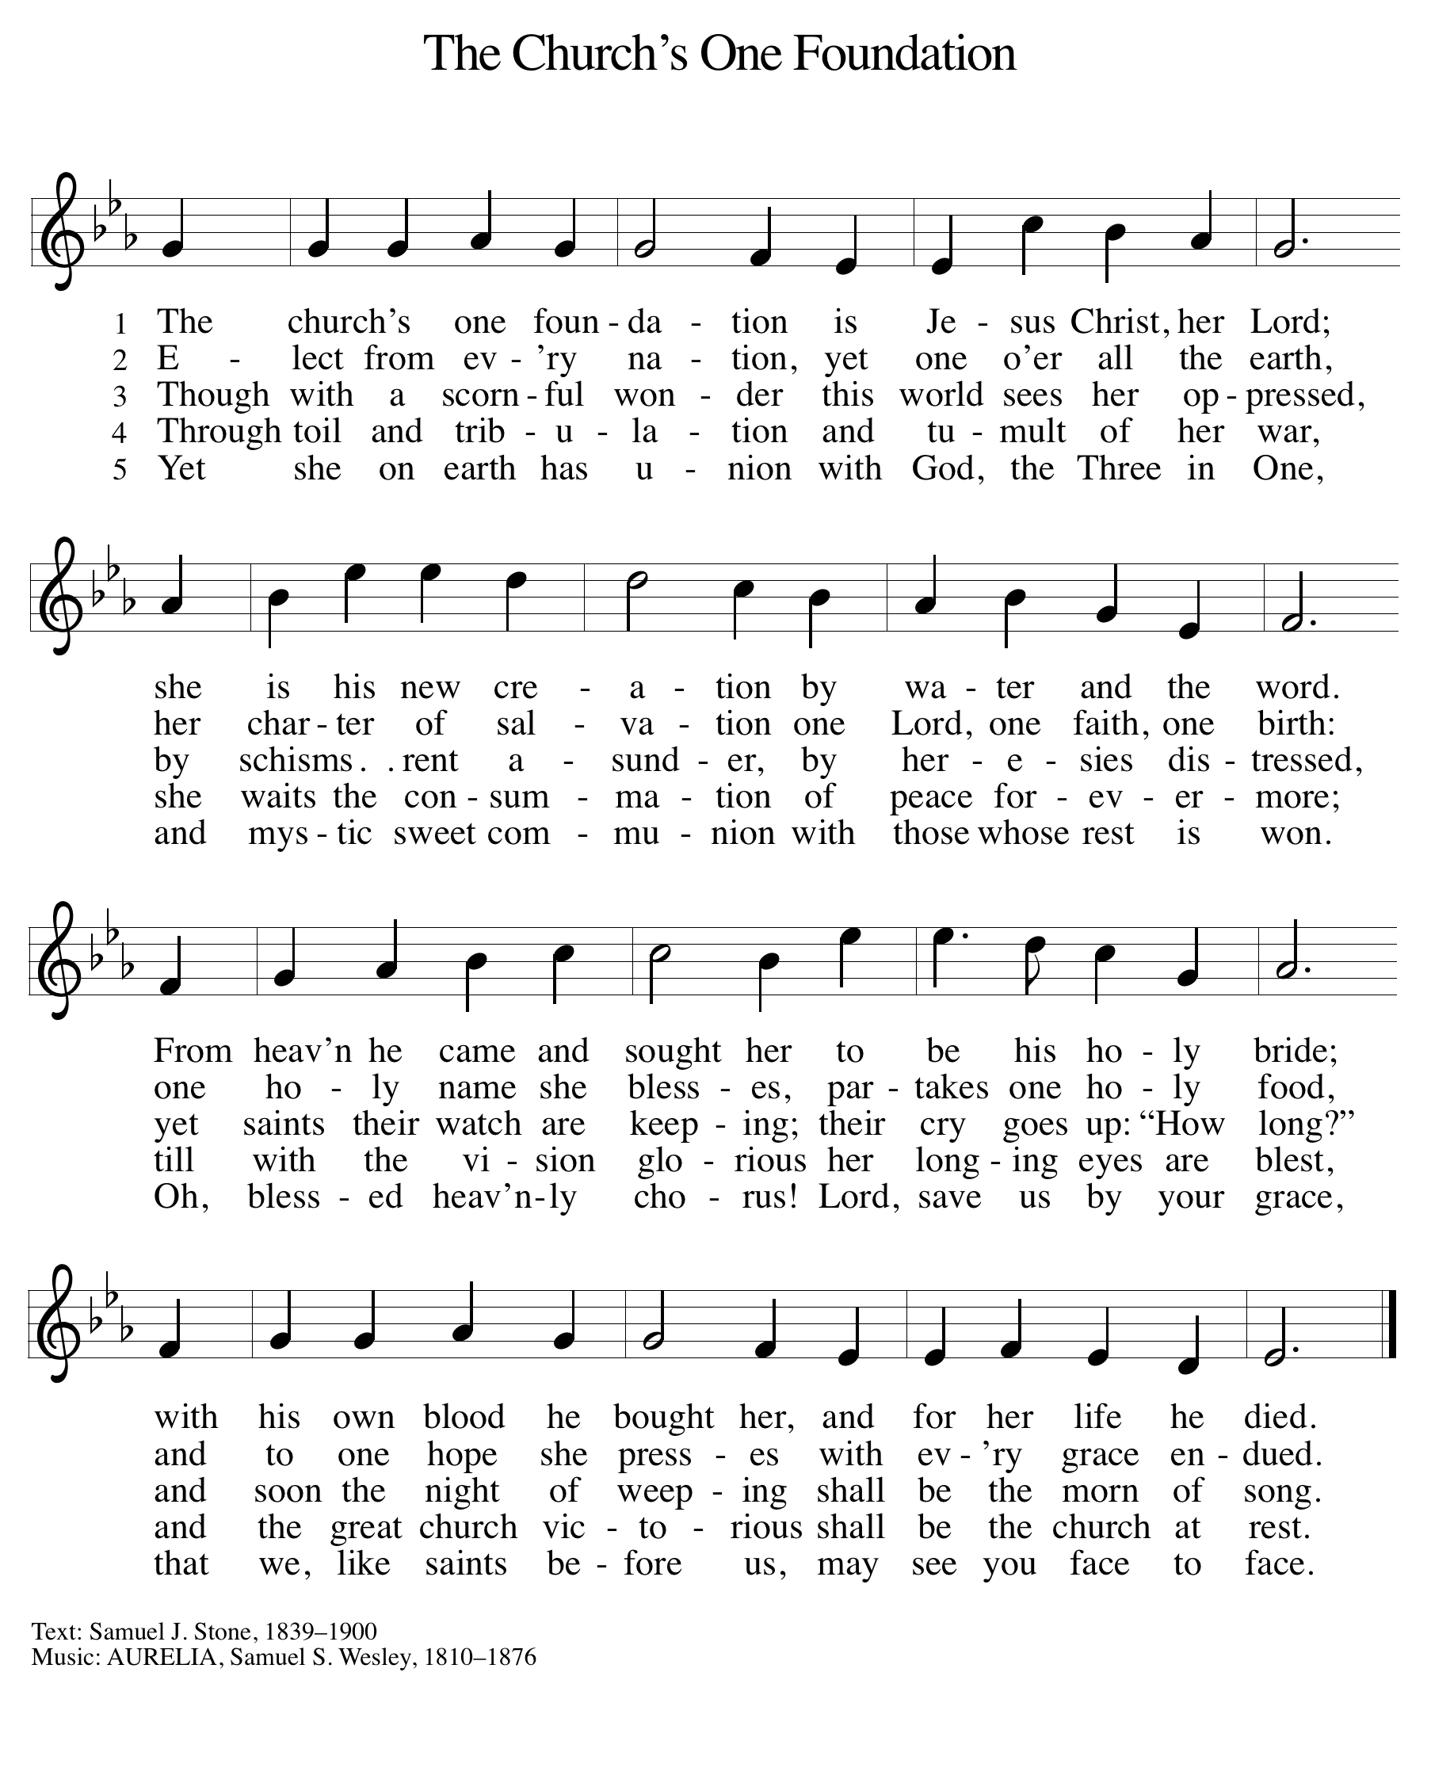
Greeting
The grace of our Lord Jesus Christ, the love of God, and the communion of the Holy Spirit be with you all.
And also with you.

Kyrie ELW Setting 1 p.98

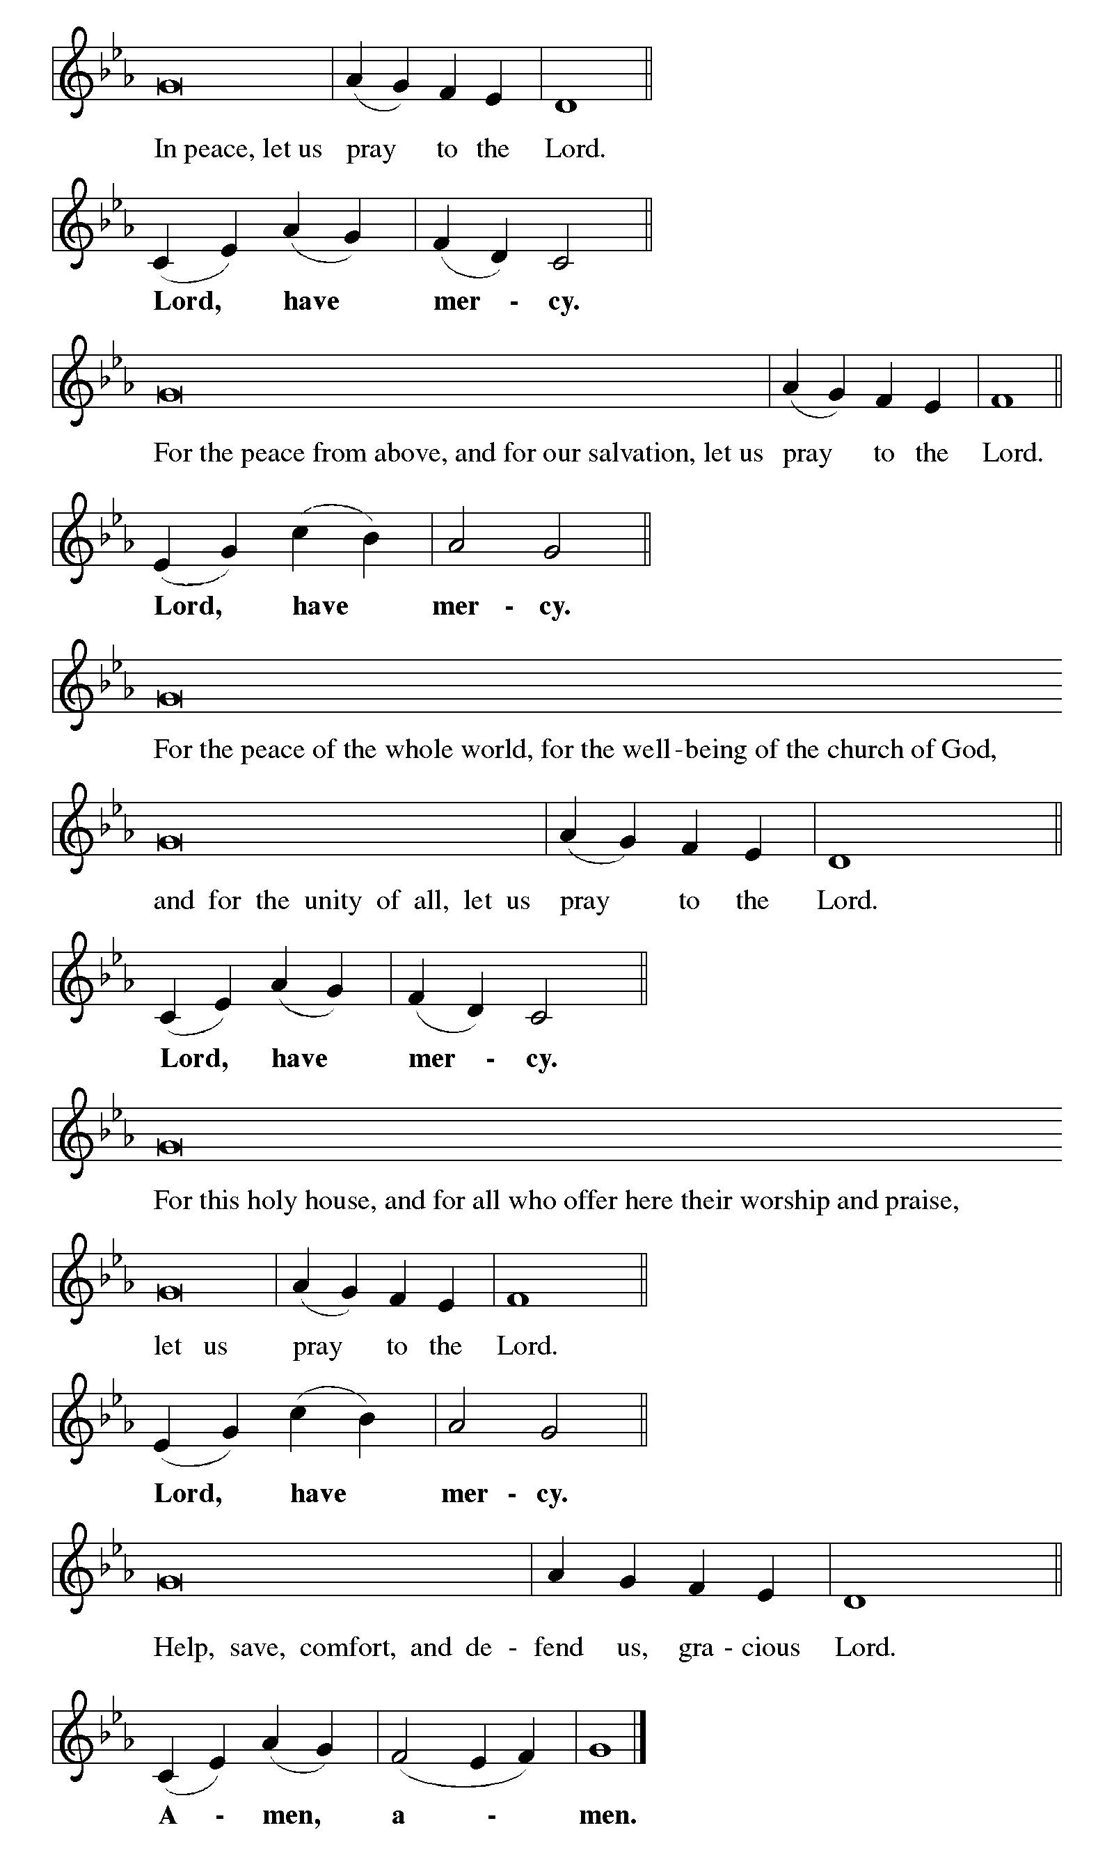

This is the Feast ELW Setting 1 p.101

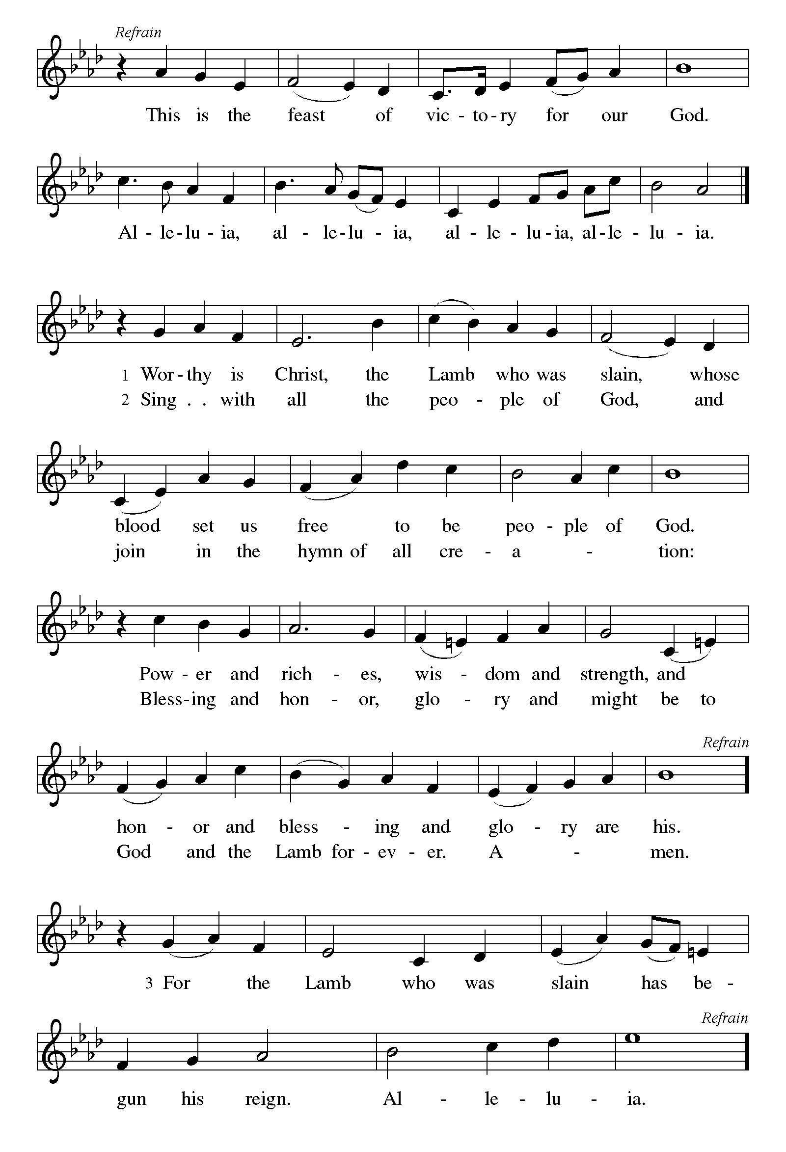

Prayer of the Day

The Lord be with you.

And also with you.

Almighty God, you have knit your people together in one communion in the mystical body of your Son, Jesus Christ our Lord. Grant us grace to follow your blessed saints in lives of faith and commitment, and to know the inexpressible joys you have prepared for those who love you, through Jesus Christ, our Savior and Lord, who lives and reigns with you and the Holy Spirit, one God, now and forever.
Amen.
+ + + WORD + + +
(Sit)
First Reading: Isaiah 25:6-9
On this mountain the Lord of hosts will make for all peoples
a feast of rich food, a feast of well-aged wines,
of rich food filled with marrow, of well-aged wines strained clear.
And he will destroy on this mountain
the shroud that is cast over all peoples,
the sheet that is spread over all nations;
he will swallow up death forever.
Then the Lord God will wipe away the tears from all faces,
and the disgrace of his people he will take away from all the
earth, for the Lord has spoken.
It will be said on that day,
Lo, this is our God; we have waited for him, so that he might save
us.
This is the Lord for whom we have waited;
let us be glad and rejoice in his salvation.

Word of God, word of life.
Thanks be to God.
Psalm: Psalm 24
Read responsively by whole verse.

The earth is the Lord’s and all that is in it,
the world and those who dwell therein.
For the Lord has founded it upon the seas
and established it upon the rivers.
Who may ascend the mountain of the Lord,
and who may stand in God’s holy place?
Those of innocent hands and purity of heart,
who do not swear on God’s being, nor do they pledge by what is false.
They shall receive blessing from the Lord
and righteousness from the God of their salvation.
Such is the generation of those who seek you, O Lord,
of those who seek your face, O God of Jacob.
Lift up your heads, O gates; and be lifted up, O everlasting doors,
that the King of glory may come in.
Who is this King of glory?
The Lord, strong and mighty, the Lord, mighty in battle!
Lift up your heads, O gates; and be lifted up, O everlasting doors,
that the King of glory may come in.
Who is this King of glory?
Truly, the Lord of hosts is the King of glory.

Second Reading: Revelation 21:1-6a
I saw a new heaven and a new earth; for the first heaven and the first earth had passed away, and the sea was no more. And I saw the holy city, the new Jerusalem, coming down out of heaven from God, prepared as a bride adorned for her husband. And I heard a loud voice from the throne saying,
“See, the home of God is among mortals.
He will dwell with them;
they will be his peoples,
and God himself will be with them;
he will wipe every tear from their eyes.
Death will be no more;
mourning and crying and pain will be no more,
for the first things have passed away.”
And the one who was seated on the throne said, “See, I am making all things new.” Also he said, “Write this, for these words are trustworthy and true.” Then he said to me, “It is done! I am the Alpha and the Omega, the beginning and the end.”

Word of God, word of life.
Thanks be to God.

(Stand)
Gospel Acclamation Allelulia! ELW Setting 8 p.188 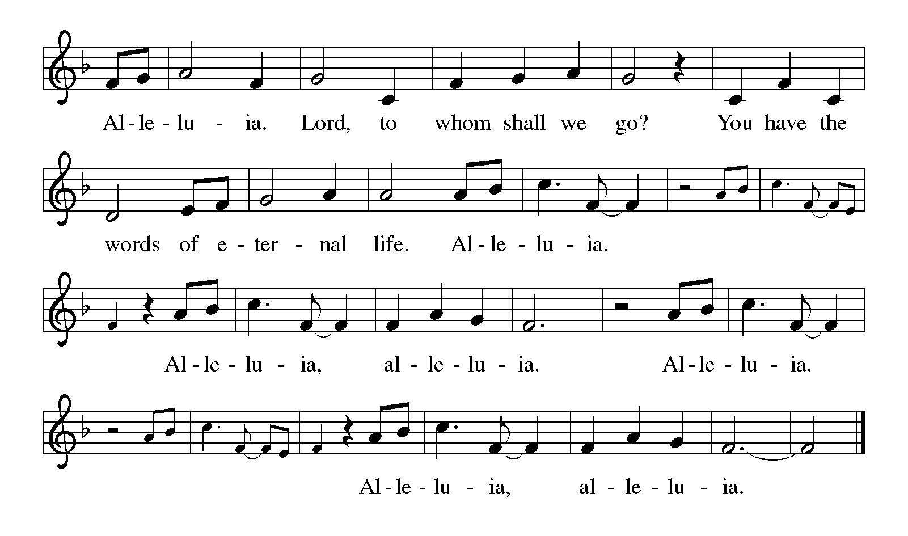

Gospel: John 11:32-44
The holy gospel according to John
Glory to you, O Lord.
When Mary came where Jesus was and saw him, she knelt at his feet and said to him, “Lord, if you had been here, my brother would not have died.” When Jesus saw her weeping, and the Jews who came with her also weeping, he was greatly disturbed in spirit and deeply moved. He said, “Where have you laid him?” They said to him, “Lord, come and see.” Jesus began to weep. So the Jews said, “See how he loved him!” But some of them said, “Could not he who opened the eyes of the blind man have kept this man from dying?”

Then Jesus, again greatly disturbed, came to the tomb. It was a cave, and a stone was lying against it. Jesus said, “Take away the stone.” Martha, the sister of the dead man, said to him, “Lord, already there is a stench because he has been dead four days.” Jesus said to her, “Did I not tell you that if you believed, you would see the glory of God?” So they took away the stone. And Jesus looked upward and said, “Father, I thank you for having heard me. I knew that you always hear me, but I have said this for the sake of the crowd standing here, so that they may believe that you sent me.” When he had said this, he cried with a loud voice, “Lazarus, come out!” The dead man came out, his hands and feet bound with strips of cloth, and his face wrapped in a cloth. Jesus said to them, “Unbind him, and let him go.”
The gospel of the Lord.
Praise to you, O Christ.

(Sit)
Children’s Message

Sermon Rev. Carrie Carnes

(Stand)
Hymn of the Day For All the Saints ELW 422

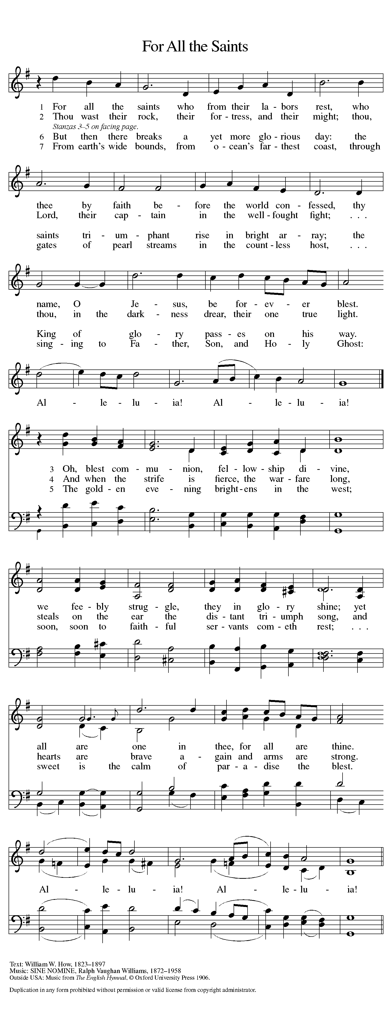

RITE OF CONFIRMATION
PRESENTATION

Dear friends, we give thanks for the gift of baptism and for these people, one with us in the body of Christ, who are making public affirmation of their baptism through the rite of Confirmation.

The following person, who desires to make public affirmation of her baptism, are presented.
Skye Clark
Let us pray.
Merciful God, we thank you for these whom you have made your own by water and the Word in baptism. You have called them to yourself, enlightened them with the gifts of your Spirit, and nourished them in the community of faith. Uphold your servants in the gifts and promises of baptism, and unite the hearts of all whom you have brought to new birth. We ask this in the name of Christ.
Amen.

Profession of Faith
I ask you to profess your faith in Christ Jesus, reject sin, and confess the faith of the church.
Do you believe in God the Father?
I believe in God, the Father almighty, creator of heaven and earth.
Do you believe in Jesus Christ, the Son of God?
I believe in Jesus Christ, God's only Son, our Lord, who was conceived by the Holy Spirit, born of the virgin Mary, suffered under Pontius Pilate, was crucified, died, and was buried; he descended to the dead. On the third day he rose again; he ascended into heaven, he is seated at the right hand of the Father, and he will come to judge the living and the dead.
Do you believe in God the Holy Spirit?
I believe in the Holy Spirit, the holy catholic church, the communion of saints, the forgiveness of sins, the resurrection of the body, and the life everlasting. Amen.

Affirmation of Baptism

You have made public profession of your faith. Do you intend to continue in the covenant God made with you in holy baptism: to live among God's faithful people, to hear the word of God and share in the Lord's supper, to proclaim the good news of God in Christ through word and deed, to serve all people, following the example of Jesus, and to strive for justice and peace in all the earth?
Each person responds:
I do, and I ask God to help and guide me.

People of God, do you promise to support these who stand before you and pray for them in their life in Christ?
We do, and we ask God to help and guide us.

Let us pray.
We give you thanks, O God, that through water and the Holy Spirit you give us new birth, cleanse us from sin, and raise us to eternal life. Stir up in (name) the gift of your Holy Spirit; confirm his/her faith, guide his/her life, empower him/her in his/her serving, give him/her patience in suffering, and bring him/her to everlasting life.
Amen.

Let us rejoice with these siblings in Christ.
We rejoice with you in the life of baptism. Together we will give thanks and praise to God and proclaim the good news to all the world.

(Sit)
Prayers of Intercession
Eternal God, you hold firm amid the changes of this world. Hear us now as we pray for the church, the world, and everyone in need.

A brief silence.

God our creator, you show us the path of life. Bless faithful people everywhere with humility as they extend compassion to those who have experienced harm in religious spaces. Cultivate healthy congregations that tell of and enact your reconciling love. God, in your mercy,
hear our prayer.
God our constant, you love our universe from beginning to end. As the seasons change, protect animals that migrate and hibernate. Bring them safely to a sheltered place and a more abundant season. God, in your mercy,
hear our prayer.
God our ruler, you write your law on human minds and hearts. Give wisdom to all elected leaders and officials to govern with insight and compassion. Make them mindful of the well-being of all people so that your world will flourish. God, in your mercy,
hear our prayer.
God our stronghold, you are present amid disaster. We pray for those affected by natural disasters. Come to the aid of all survivors of earthquakes, famines, floods, hurricanes, and wildfires, and the first responders who support them. Calm their fear, supply their need, and be the solid ground beneath their feet. God, in your mercy,
hear our prayer.
God our guide, you are greater than we can imagine. Surround congregations with your expansive inclusion. Be present in the midst of disagreements, differences, and questions. Unite people of diverse viewpoints in the love of Christ. God, in your mercy,
hear our prayer.
God our beginning and our end, your beloved people shine like the brightness of the sky. We thank you for the lives of all who rest in your eternal mercy, from famous saints to the people we have loved. We lift up Annie in our prayers today, as she lost her brother, Thomas last year. Assure us of your resurrection promise. God, in your mercy,
hear our prayer.

Lord of every time, countless are the multitudes you have called by name and gathered to yourself. Comfort us as we grieve those who have died in the past year:

Donna Bickerton Marlene Nelson
Donna Mae Cordes Carolina Ramsell
Joann Lundeen Joyce Swedlund

God, in your mercy,
hear our prayer.

Receive our prayers in the name of Jesus Christ our Savior, until that day when you gather all creation around your throne where you will reign forever and ever. Amen.

Peace
The peace of Christ be with you always.
And also with you.

+ + + MEAL + + +

Offering Song Behold a Host Arrayed In White Arr. Bradley Ellingboe
Senior Choir

(Stand)
Offering Prayer
God of abundance,
you cause streams to break forth in the desert
and manna to rain from the heavens.
Accept the gifts you have first given us.
Unite them with the offering of our lives
to nourish the world you love so dearly;
through Jesus Christ, our Savior and Lord.
Amen.

Great Thanksgiving
The Lord be with you.
And also with you.
Lift up your hearts.
We lift them to the Lord.
Let us give thanks to the Lord our God.
It is right to give our thanks and praise.

It is indeed right, our duty and our joy,
that we should at all times and in all places
give thanks and praise to you, almighty and merciful God,
through our Savior Jesus Christ.
By the witness of your saints
you show us the hope of our calling
and strengthen us to run the race set before us,
that we may delight in your mercy and rejoice with them in glory.
And so, with all the saints,
with the choirs of angels and all the hosts of heaven,
we praise your name and join their unending hymn:

Holy, Holy, Holy Lord ELW Setting 8 p.190
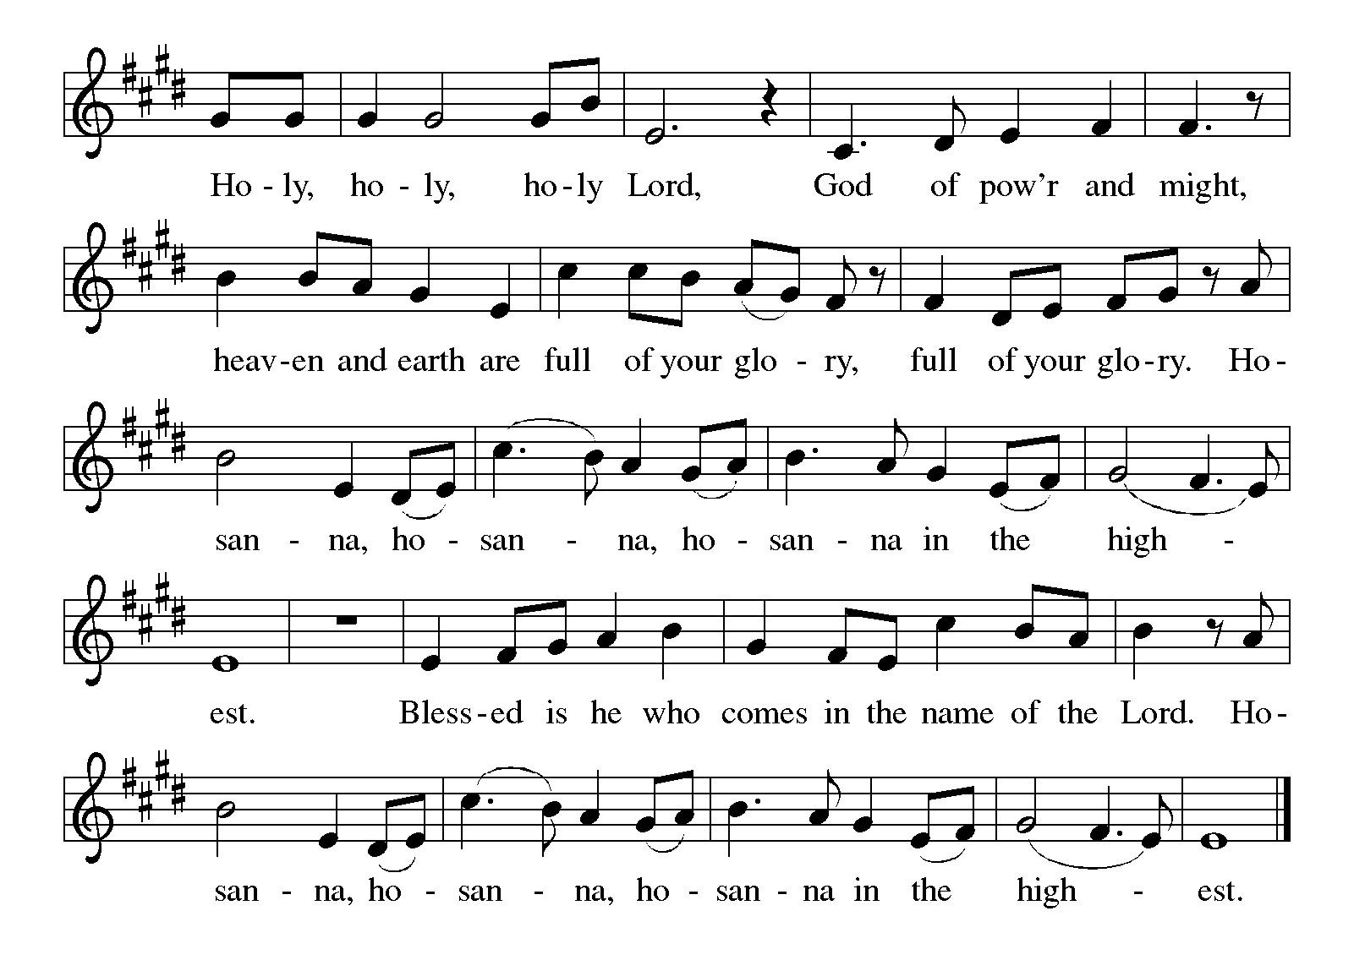

Eucharistic Prayer
Blessed are you, O God,
creator of heaven and earth.
You rescued your covenant people,
led them on all their journeys,
and taught them by the prophets.
You so loved the world
that you gave your only Son,
so that everyone who believes in him
may not perish but may have eternal life.

In the night in which he was betrayed,
our Lord Jesus took bread,
and gave thanks; broke it,
and gave it to his disciples,
saying: Take and eat;
this is my body, given for you.
Do this for the remembrance of me.

Again, after supper,
he took the cup, gave thanks,
and gave it for all to drink,
saying: This cup
is the new covenant in my blood,
shed for you and for all people
for the forgiveness of sin.
Do this for the remembrance of me.

As often as we eat this bread
and drink this cup,
we proclaim the Lord’s death
until he comes.
Christ has died.
Christ is risen.
Christ will come again.

Pour out your Holy Spirit
in this meal,
and make us one
in this community of faith
and with your people
throughout the world.
Glory and praise to you, O God,
Author of life,
Word made flesh,
Power of the Most High,
now and forever.
Amen.
The Lord’s Prayer
Let us pray with confidence in the words our Savior gave us.
Our Father in heaven, hallowed be your name, your kingdom come, your will be done, on earth as in heaven. Give us today our daily bread. Forgive us our sins as we forgive those who sin against us. Save us from the time of trial and deliver us from evil. For the kingdom, the power, and the glory are yours, now and forever. Amen.

Invitation to Communion
A feast of love is offered here for you and for all the saints.

All are welcome to receive communion at Trinity Lutheran Church. If you wish to receive you may come forward as dismissed by the usher and will be given a wafer in the center aisle. Then you may take a small cup from the tray. Red wine is along the outside, and white grape juice is located in the center of the tray. Gluten free bread is also available. Place empty cups in the bowls located at the side aisle as you return to your pew. If you prefer to receive a blessing rather than communion, you may indicate that by crossing your arms over your chest as you come forward.

(Sit)
Distribution of Communion

Lamb of God ELW Setting 8 p.191
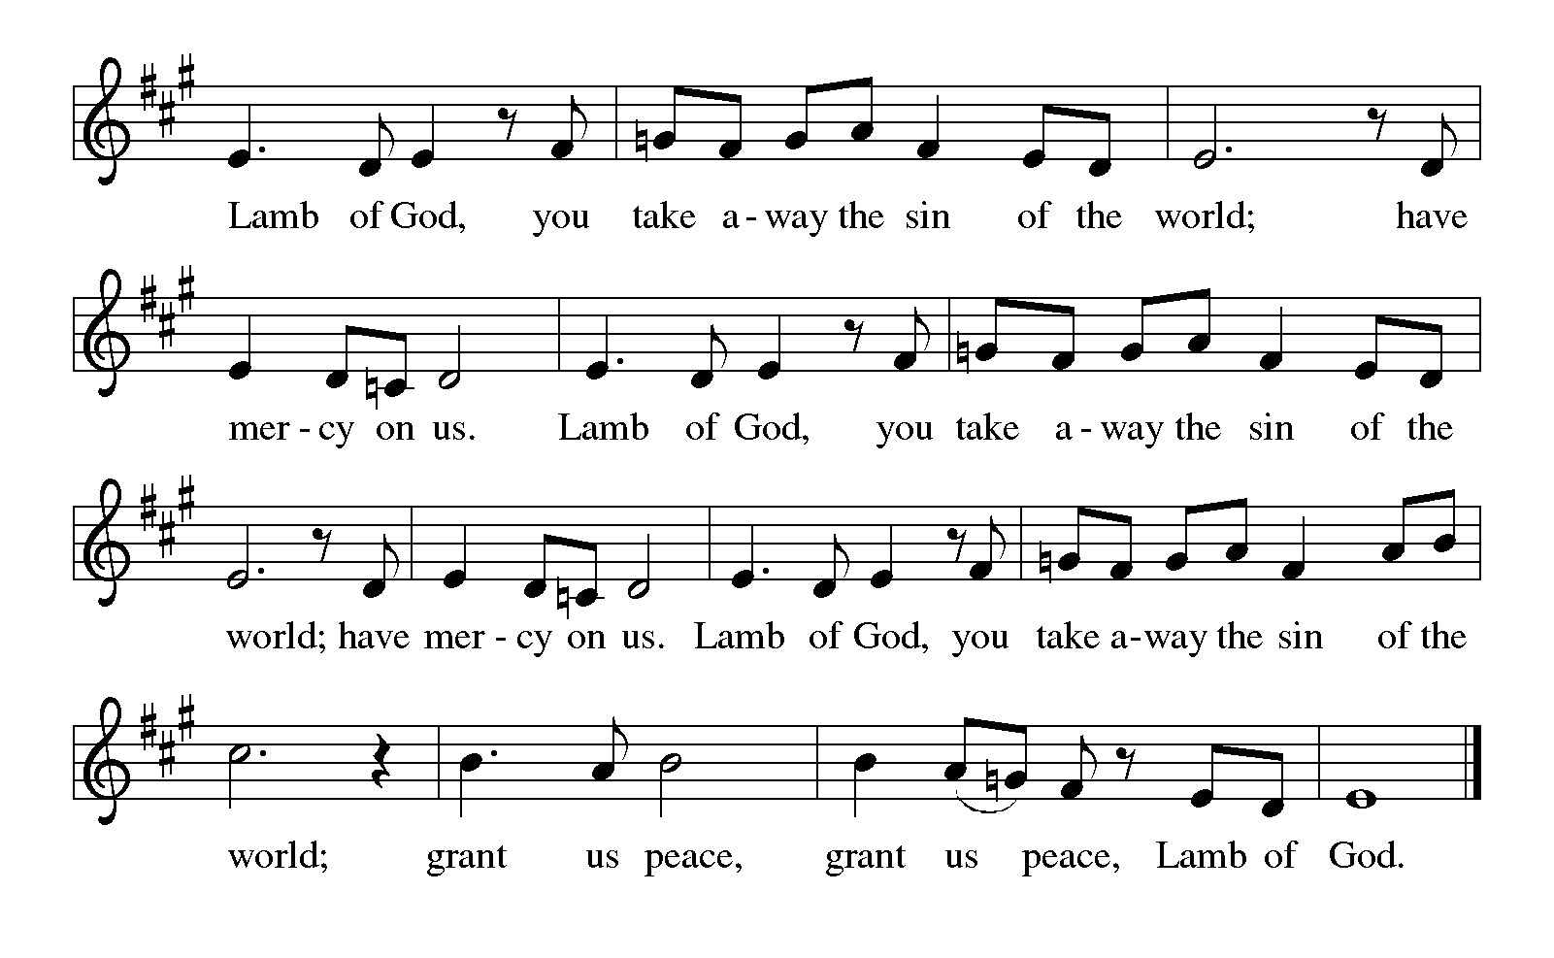

Jerusalem, My Happy Home Robert Hobby, Marilyn Biery, Callahan
(Stand)
Post Communion Blessing
The body and blood of our Lord Jesus Christ strengthen us and keep us in God’s grace.
Amen.

Prayer After Communion
Lord of life,
in the gift of your body and blood
you turn the crumbs of our faith into a feast of salvation.
Send us forth into the world with shouts of joy,
bearing witness to the abundance of your love
in Jesus Christ, our Savior and Lord.
Amen.

+ + + SENDING + + +
Blessing
People of God,
you are Christ’s body,
bringing new life to a suffering world.
The holy Trinity, ☩ one God,
bless you now and forever.
Amen.

Dismissal
Go in peace. The living Word dwells in you.
Thanks be to God.
Postlude For All the Saints Wayne Wold
From Sundays and Seasons.com. Copyright 2020 Augsburg Fortress. All rights reserved. Reprinted by permission under Augsburg Fortress Liturgies Annual License #23928. New Revised Standard Version Bible, copyright 1989, Division of Christian Education of the National Council of the Churches of Christ in the United States of America. Used by permission. All rights reserved.

Affirming her baptism: Skye Clark


This week’s altar flowers are given by JoAnn Lakis & Family, To the Glory of God in memory of Mr. Louis Lakis for his birthday.


This week’s radio program was sponsored by Brenda Patterson giving in celebration of All Saints Sunday.

Worship Participants
Audio: Julie A’Hearn
Video: Sarah Brakenbury
Usher: Julie A’Hearn
Assisting Minister: Jen Robinson
Reader and Communion Assistant: Laura Saey
Closing Duties: Julie A’Hearn
Communion Set-Up: Marilyn Gehring
Organist: Bette Mohr
Pastor: Rev. Carrie Carnes
Readings for Sunday, November 14th
First Reading: Daniel 12:1-3
Psalm: Psalm 16
Second Reading: Hebrews 10:11-14[15-18]19-25
Gospel: Mark 13:1-8

This Week at Trinity

Sunday, November 7th
Bell Choir Meet 10:45 am
Trinity Youth Night 5:00 pm

Tuesday, November 9th
The Tie That Binds 9:00 am
Play Group Canceled
Executive Committee 7:00 pm

Wednesday November 10th
Church Night 4:30 pm
Senior Choir 7:00 pm

Sunday November 14th
Commitment Sunday: Giving in Celebration

Announcements:
Commitment Sunday is the 14th: Please bring your completed Time & Ability Forms and Pledge Cards to Worship service with you.

This year there are 3 forms of Time & Ability Sheets consisting of Adult, Young Adult, and Youth. The Young Adult and Youth forms have different information/options on them so feel free to fill out and/or help your child complete both forms to make the best use of time and abilities.
Questions? Please contact the office for assistance!
Rev. Carrie Carnes, Pastor, Out-of-office: Friday
Cell phone: 618-803-8778
Church Office: Phone 309-343-4191
Hours 8:00 am- 1:00 pm, Monday-Friday
Sunday Worship at 9:30 am; Holy Communion
Sunday Radio Ministry at 9:30 am on WRAM – 1330 AM, Facebook
www.trinitygalesburg.org
trinitylutheran@trinitygalesburg.org
mittee and Worship Committee. Finance committee will not meet. Childcare provided for children of committee members.

Vision Statement
Developing Disciples – Connecting to Christ

Mission Statement
Led by the Spirit, we receive Christ’s love, share God’s forgiving grace, and reach out to welcome, encourage and serve all.

Welcome Statement
Members of Trinity Lutheran Church are freed by the Gospel to seek reconciliation and wholeness in a world that is frequently an unloving place. We extend welcome to ALL, including people of all gender identities and sexual orientations, whether believer, doubter, or seeker. In Christ’s love we invite you, so that led by the power of the Holy Spirit we will join together to strive for justice, peace and love in all the earth.

Our Guiding Principles
1. Jesus Christ is Lord and Savior.
2. We faithfully worship through Word and Sacrament.
3. We invite and welcome everyone.
4. We engage all generations in education and ministry.
5. We serve local and global communities.

