

**Streams of Living Water: Faith in Action**

**Trinity Lutheran Church**

Nineteenth Sunday After Pentecost

September 29th, 2024

**Trinity Lutheran Church**

304 E. Ferris Street

Galesburg, IL 61401

*“the welcome place”*

Nineteenth Sunday After Pentecost

September 29th, 2024

Someone who isn’t part of Jesus’ own circle is casting out demons in Jesus’ name, and the disciples want him stopped. They appeal to Jesus, as Joshua did to Moses about the elders who prophesied without official authorization. Like Moses, Jesus refuses to see this as a threat. Jesus welcomes good being done in his name, even when it is not under his control. The circle we form around Jesus’ word must be able to value good being done in ways we wouldn’t do it, by people we can’t keep tabs on.

**+++GATHERING+++**

**Prelude** Ye Watchers and Ye Holy Ones Wayne Wold

**Welcome & Announcements - Please Sign Friendship Registry**

*The red ELW hymnal and the purple ACS hymnal are in the pew racks*

**Temple Talk** Lisa Shafer

*(Stand)*

**Thanksgiving at the Font**

*All may make the sign of the cross, the sign that is marked at baptism, as the presiding minister begins.*

Joined to Christ in the waters of baptism,

clothed with God’s mercy and forgiveness,

let us give thanks for the gift of baptism.

Holy God, fountain of living water,

source of mercy, tender and mighty,

you are clothed with majesty and splendor.

Your steadfast love fills the earth.

**Your steadfast love fills the earth.**

Your love flows through water,

satisfying the thirst of all living things,

sustaining life in this community,

nourishing and delighting us.

We bless you for these gifts of water:

Your steadfast love fills the earth.

**Your steadfast love fills the earth.**

Your love flows through water,

a sign of your saving power:

Noah and the animals survive the flood,

Hagar discovers your well.

The Israelites escape through the sea,

and they drink from your gushing rock.

Naaman washes his leprosy away,

and the Samaritan woman will never be thirsty again.

Your steadfast love fills the earth.

**Your steadfast love fills the earth.**

Your love flows through the water of baptism

joined to your life-giving Word:

your well of mercy and cleansing flood,

your sea of deliverance from death into life,

your healing river washing sin away,

your living water springing up to eternal life.

Your steadfast love fills the earth.

**Your steadfast love fills the earth.**

Shower us with your Holy Spirit.

Fill us with your love.

Clothe us and all your people with grace.

Embolden us to do justice.

Bless us to love mercy.

Guide us to walk humbly with you,

whom we thank and praise, through Jesus Christ,

in the unity of the Holy Spirit, now and forever.

**Amen.**

**Gathering Hymn** ELW (red) #424 Ye Watchers and Ye Holy Ones

**Greeting**

The grace of our Lord Jesus Christ, the love of God, and the communion of the Holy Spirit be with you all.

**And also with you.**

**Kyrie**  ELW (red), Setting 8, pg. 184-185

*(All sing refrain, cantor will sing verses)*****

1. For peace in the world, for the health of the church, for the unity of all; for this holy house, for all who worship and praise,

let us pray to the Lord, let us pray to the Lord

1. That we may live out your impassioned response to the hungry and the poor; that we may live out truth and justice and grace,

let us pray to the Lord, let us pray to the Lord

1. For peace in our hearts, for peace in our homes, for friends and family; for life and for love, for our work and our play,

let us pray to the Lord, let us pray to the Lord

1. For your Spirit to guide; that you center our lives in the water and the Word; that you nourish our souls with your body and blood,

let us pray to the Lord, let us pray to the Lord.

**This is the Feast** ELW (red), Setting 8, pg. 187-188



**Prayer of the Day**

The Lord be with you.

**And also with you.**

Everlasting God, you have wonderfully established the ministries of angels and mortals. Mercifully grant that as Michael and the angels contend against the cosmic forces of evil, so by your direction they may help and defend us here on earth, through your Son, Jesus Christ our Lord, who lives and reigns with you and the Holy Spirit, one God whom we worship and praise with angels and archangels and all the company of heaven, now and forever.

**Amen**

*(Sit)*

**+++WORD+++**

**First Reading: Daniel 10:10-14; 12:1-3**

10A hand touched me and roused me to my hands and knees. 11He said to me, “Daniel, greatly beloved, pay attention to the words that I am going to speak to you. Stand on your feet, for I have now been sent to you.” So while he was speaking this word to me, I stood up trembling. 12He said to me, “Do not fear, Daniel, for from the first day that you set your mind to gain understanding and to humble yourself before your God, your words have been heard, and I have come because of your words. 13But the prince of the kingdom of Persia opposed me twenty-one days. So Michael, one of the chief princes, came to help me, and I left him there with the prince of the kingdom of Persia, 14and have come to help you understand what is to happen to your people at the end of days. For there is a further vision for those days.  
 12:1“At that time Michael, the great prince, the protector of your people, shall arise. There shall be a time of anguish, such as has never occurred since nations first came into existence. But at that time your people shall be delivered, everyone who is found written in the book. 2Many of those who sleep in the dust of the earth shall awake, some to everlasting life, and some to shame and everlasting contempt. 3Those who are wise shall shine like the brightness of the sky, and those who lead many to righteousness, like the stars forever and ever.”

Word of God, word of life.

**Thanks be to God.**

****Psalm 103:1-5, 20-22**  *(Responsively by whole verse)*

1Bless the Lord, **|** O my soul,  
  and all that is within me, bless God’s **|** holy name.  
 2**Bless the Lord, | O my soul,**  
  **and forget not | all God’s benefits—**  
 3who forgives **|** all your sins  
  and heals all **|** your diseases;  
 4**who redeems your life | from the grave**  
  **and crowns you with steadfast | love and mercy;**  
 5who satisfies your desires **|** with good things  
  so that your youth is renewed **|** like an eagle’s.  
 20**Bless the Lord, you angels, you mighty ones who | do God’s bidding,**  
  **who obey the voice | of God’s word.**  
 21Bless the Lord, all you **|** hosts of God,  
  you servants who **|** do God’s will.  
 22**Bless the Lord, all you works of God, in all places | where God rules;**  
  **bless the Lord, | O my soul.**

**Second Reading: Revelation 12:7-12**

7War broke out in heaven; Michael and his angels fought against the dragon. The dragon and his angels fought back, 8but they were defeated, and there was no longer any place for them in heaven. 9The great dragon was thrown down, that ancient serpent, who is called the Devil and Satan, the deceiver of the whole world—he was thrown down to the earth, and his angels were thrown down with him.  
 10Then I heard a loud voice in heaven, proclaiming,  
 “Now have come the salvation and the power  
  and the kingdom of our God  
  and the authority of his Messiah,  
 for the accuser of our comrades has been thrown down,  
  who accuses them day and night before our God.  
 11But they have conquered him by the blood of the Lamb  
  and by the word of their testimony,  
 for they did not cling to life even in the face of death.  
 12Rejoice then, you heavens  
  and those who dwell in them!  
 But woe to the earth and the sea,  
  for the devil has come down to you  
 with great wrath,  
  because he knows that his time is short!”

Word of God, word of life.

**Thanks be to God.**

*(Stand)*

**Gospel Acclamation** ELW (red) Setting 8, pg.188

**Gospel: Luke 10:17-20**

The holy gospel according to Luke.

**Glory to you, O Lord.**

17The seventy returned with joy, saying, “Lord, in your name even the demons submit to us!” 18He said to them, “I watched Satan fall from heaven like a flash of lightning. 19See, I have given you authority to tread on snakes and scorpions, and over all the power of the enemy; and nothing will hurt you. 20Nevertheless, do not rejoice at this, that the spirits submit to you, but rejoice that your names are written in heaven.”

The gospel of the Lord.

**Praise to you, O Christ.**

*(Sit)*

**Children’s Message**

**Sermon** Rev. Dr. Carrie Carnes

*(Stand)*

**Hymn of the Day** TLH #254 Lord God, We All to Thee Give

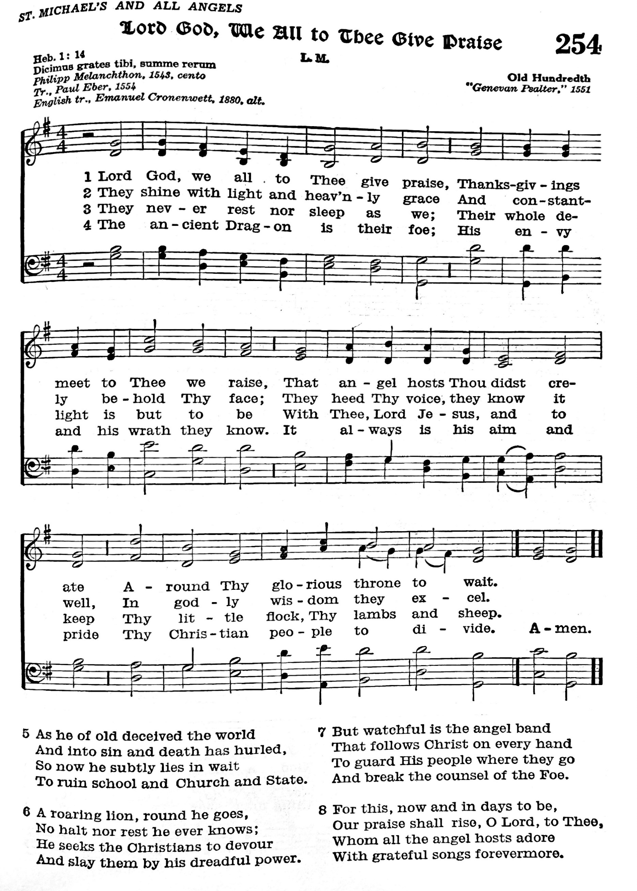 Praise (tune: Old Hundredth)

**Apostles Creed**

*Let us join together in the confession of our faith.*

**I believe in God, the Father almighty,**

**creator of heaven and earth.**

**I believe in Jesus Christ, God’s only Son, our Lord,**

**who was conceived by the Holy Spirit,**

**born of the virgin Mary,**

**suffered under Pontius Pilate,**

**was crucified, died, and was buried;**

**he descended to the dead.\***

**On the third day he rose again;**

**he ascended into heaven,**

**he is seated at the right hand of the Father,**

**and he will come to judge the living and the dead.**

**I believe in the Holy Spirit,**

**the holy catholic church,**

**the communion of saints,**

**the forgiveness of sins,**

**the resurrection of the body,**

**and the life everlasting. Amen.**

*(Sit)*

**Prayers of Intercession**

Drawn together in the power of the Holy Spirit, we pray with confidence for the church, God’s good creation, and all who are in need.

*A brief silence.*

We pray for the church and its leaders: for council members and music ministers, deacons, pastors, and bishops. Make us faithful messengers of your love in a world hungry for good news. Hear us, O God.

**Your mercy is great.**

We pray for the flourishing of all that you have made, for birds and squirrels, spiders and whales, oak trees and humble grasses. Renew prairies and forests, tundra and wetlands, that they sustain all who make their home there. Hear us, O God.

**Your mercy is great.**

We pray for the peoples of the world and for their leaders. Where conflict and violence reign, bring peace; wherever there is oppression or discrimination, bring liberation. Guide all in power to protect those who are most vulnerable. Hear us, O God.

**Your mercy is great.**

We pray for all who are suffering this day, especially Keith, Marilyn, Jim, Jenna, Janis, and Dewey. Accompany people fleeing from danger and encourage all who help them on their journeys. Abide with all who are in prison or detention centers. Reassure them of your steadfast love. Hear us, O God.

**Your mercy is great.**

We pray for all who question their faith. Fill our dry wells with your living water and reassure all who doubt of your boundless grace. Let us accompany all in discernment with open hearts and tender care. Hear us, O God.

**Your mercy is great.**

We offer thanksgiving for our beloved dead. At the close of our earthly pilgrimage, gather us with Michael and all the saints and angels into everlasting life in you. Hear us, O God.

**Your mercy is great.**

We offer to you these prayers as well as those we now name to you either aloud or in our hearts

We entrust these and all our prayers to you, holy God, in the name of your beloved child, Jesus Christ, our Savior.

**Amen.**

**Peace**

The peace of Christ be with you always.

**And also with you.**

**+++MEAL+++**

**Offering Music** Trio on Lasst Uns Erfreuen Matthew Machemer

*(Stand)*

**Offering Prayer**

Blessed are you, O God,

source of every gift of your creation.

By these gifts and with our lives,

help us to serve one another and all in need,

through Jesus Christ, our Savior and Lord.

**Amen.**

**Great Thanksgiving**

The Lord be with you.

**And also with you.**

Lift up your hearts.

**We lift them up to the Lord.**

Let us give thanks to the Lord our God.

**It is right to give our thanks and praise.**

It is indeed right, our duty and our joy,

that we should at all times and in all places

give thanks and praise to you, almighty and merciful God,

through our Savior Jesus Christ;

who on this day overcame death and the grave,

and by his glorious resurrection opened to us the way of everlasting life.

And so, with all the choirs of angels,

with the church on earth and the hosts of heaven,

we praise your name and join their unending hymn:

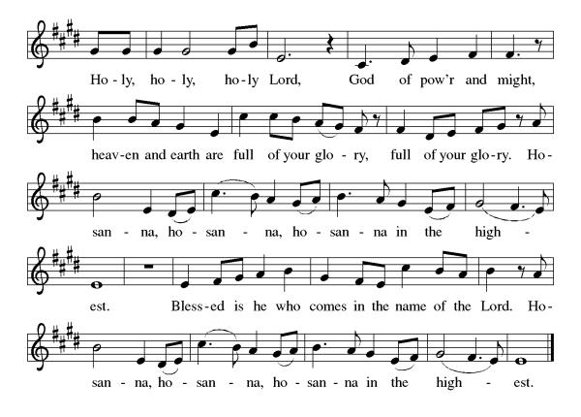**Holy, Holy, Holy ELW (red), Setting 8, pg. 190**

You are indeed holy, almighty and merciful God.

You are most holy,

and great is the majesty of your glory.

You so loved the world that you gave your only Son,

so that everyone who believes in him may not perish

but have eternal life.

We give you thanks for his coming into the world

to fulfill for us your holy will

and to accomplish all things for our salvation.

In the night in which he was betrayed,

our Lord Jesus took bread, and gave thanks;

broke it, and gave it to his disciples, saying:

Take and eat; this is my body, given for you.

Do this for the remembrance of me.

Again, after supper, he took the cup, gave thanks,

and gave it for all to drink, saying:

This cup is the new covenant in my blood,

shed for you and for all people for the forgiveness of sin.

Do this for the remembrance of me.

For as often as we eat of this bread and drink from this cup,

we proclaim the Lord’s death until he comes.

**Christ has died. Christ is risen. Christ will come again.**

Remembering, therefore, his salutary command,

his life-giving passion and death, his glorious resurrection and ascension,

and the promise of his coming again,

we give thanks to you, O Lord God Almighty,

not as we ought but as we are able;

we ask you mercifully to accept our praise and thanksgiving

and with your Word and Holy Spirit to bless us, your servants,

and these your own gifts of bread and wine,

so that we and all who share in the body and blood of Christ

may be filled with heavenly blessing and grace,

and, receiving the forgiveness of sin,

may be formed to live as your holy people

and be given our inheritance with all your saints.

To you, O God, Father, Son, and Holy Spirit,

be all honor and glory in your holy church, now and forever.

**Amen.**

**The Lord’s Prayer**

**Our Father in heaven,** **hallowed be your name,**

**your kingdom come,** **your will be done,** **on earth as in heaven.** **Give us today our daily bread.** **Forgive us our sins**

**as we forgive those** **who sin against us.** **Save us from the time of trial** **and deliver us from evil.** **For the kingdom, the power,** **and the glory are yours,** **now and forever. Amen.**

**Invitation to Communion**

Jesus welcomes you to this table.

Come, here is your God.

*All are welcome to receive communion at Trinity Lutheran Church. If you wish to receive you may come forward as dismissed by the usher and will be given a wafer in the center aisle. Then you may take a small cup from the tray. Red wine is along the outside, and white grape juice is located in the center of the tray. Gluten free bread is also available. Place empty cups in the bowls located at the side aisle as you return to your pew. If you prefer to receive a blessing rather than communion, you may indicate that by crossing your arms over your chest as you come forward.*

(Sit)

**Distribution of Communion**

****Lamb of God ELW (red), Setting 8, pg. 191

*Communion music Chant on Lasst Matthew Machemer*

*Uns Erfreuen*

**Post Communion Hymn** ELW (red) #531 The Trumpets Sound

*(Stand)*

**Prayer After Communion**

Holy God,

you have welcomed us to this meal

and fed us with dignity at your table.

Send us now to welcome others

and to be at peace with one another,

through Jesus Christ our Lord.

**Amen.**

**+++SENDING+++**

**Blessing**

God all mighty,

God most merciful

☩ bless you, keep you,

and give you peace.

**Amen.**

**Sending Hymn** ELW (red) #834 Immortal, Invisible

**Dismissal**

Go in peace. Follow Jesus.

**Thanks be to God.**

**Postlude**  Ye Watchers and Ye Holy Ones Donald Busarow

From Sundays and Seasons.com. Copyright 2024. Augsburg Fortress. All rights reserved. Reprinted by permission under Augsburg Fortress Liturgies Annual License #23928. New Revised Standard Version Bible, copyright 1989, Division of Christian Education of the National Council of the Churches of Christ in the United States of America. Used by permission. All rights reserved.

***As you leave, please take a moment to greet one another.***

**This week’s radio broadcast** is sponsored by Caorlyn Park

*In Memory of Shirley Park’s birthday*

**Worship Participants**

Audio: Matt Warner

Video Bill Sime

Ushers: Erin & Cecilia Crawford, Roberta Majors

Communion Setup: Hillary Hoffman

Assisting Minister: Julie Wiegand

Reader: Laura Saey

Wine Servers: Jennifer Robinson, Sandra Gray

Coffee Fellowship: Erin & Lucia Crawford

Acolyte: Henry Gray

Closing Duties: Julie Wiegand

**Announcements**

**Coffee Fellowship** is immediately after service.

**A Draft of the New Constitution** is available in the Narthex. If you would prefer a copy via email, please contact the office.

**Adult Education: Conversations on Christian Nationalism**

Class is at 6 pm this Tuesday! We will gather to explore the implications of Christian Nationalism, This study offers a unique opportunity to deepen our understanding of how our faith intersects with civic life and to reflect on how we, as Lutherans, can uphold the principles of religious freedom and the separation of church and state. All are welcome to join us in these important conversations.

|  |  |
| --- | --- |
| **Prayer List:** If you or loved ones need prayers, please fill out the salmon-colored form located on the bulletin table in the Narthex, and return it to the Office mailbox or drop it in the offering plate. | |
| **Name** | **Prayer** |
| All Farmers During Harvest | Prayers for Health & Safety |
| Keith Majors | Prayers for Healing & Recovery |
| Jim Woods | Prayers for Healing & Recovery |
| Marilyn A’Hearn | Prayers for Healing & Recovery |
| The Friends & Family of Holly | Prayers for Peace |
| Jenna | Prayers for Health |
| Janis | Prayers for Healing |
| Dewey | Prayers for Healing |

|  |  |  |
| --- | --- | --- |
| **This Week at Trinity** | | |
| Sunday, Sept. 29th | 9:30 am | Worship |
|  | 10:30 am | Coffee Fellowship |
|  | 10:45 am | Sunday School |
|  | 5:30 pm | Youth Group |
| Saturday, Oct. 5th | 5:00 pm | Worship **led by Grace** |

Rev. Dr. Carrie Carnes, Pastor, Out-of-office: Friday

Cell phone: 618-803-8778

Church Office: Phone 309-343-4191

Hours 8:30 am – 12:30 pm, Monday-Friday

1st & 3rd Saturdays; Worship 5:00 pm; Holy Communion

Sunday Worship at 9:30 am; Holy Communion

Sunday Radio Ministry at 9:30 am on WRAM – 1330 AM, Facebook

[trinitylutheran@trinitygalesburg.org](mailto:trinitylutheran@trinitygalesburg.org)

mittee and Worship Committee. Finance committee will not meet. Childcare provided for children of committee members.

**Vision Statement**

**Developing Disciples – Connecting to Christ**

**Mission Statement**

**Led by the Spirit, we receive Christ’s love, share God’s forgiving grace, and reach out to welcome, encourage and serve all.**

**Welcome Statement**

At Trinity Lutheran Church, we believe God’s grace is extended to everyone. Members of Trinity Lutheran Church are freed by the Gospel to seek reconciliation and wholeness. We welcome people of all sexual orientations, gender identities, and gender expressions, whether believer, doubter, or seeker. In Christ's love we invite you, so that led by the power of the Holy Spirit we will join together to strive for racial equity, justice, peace, and love in all the earth.

**Our Guiding Principles**

1. Jesus Christ is Lord and Savior.

2. We faithfully worship through Word and Sacrament.

3. We invite and welcome everyone.

4. We engage all generations in education and ministry.

5. We serve local and global communities.