

**Trinity Lutheran Church**

Fourth Sunday of Lent

March 30th, 2025

**Trinity Lutheran Church**

304 E. Ferris Street

Galesburg, IL 61401

*“the welcome place”*

Fourth Sunday of Lent

March 30th, 2025

**+++GATHERING+++**

The psalm sets the tone this day: “Happy are they whose transgressions are forgiven, and whose sin is put away!” Happy are those who have “become the righteousness of God” in the merits of Christ Jesus. Happy are those for whom the forgiveness of God has “rolled away . . . the disgrace” of former times. Happy is the father at the return of his prodigal son. Happy are we that our sins are forgiven for Jesus’ sake. Rejoice!

**Prelude**……..….”Variations on an American Hymn”….Gordon Young

**Welcome & Announcements - Please Sign Friendship Registry**

*The red ELW hymnal and the purple ACS hymnal are in the pew racks*

*(Stand)*

**Confession & Forgiveness**

*All may make the sign of the cross, the sign that is marked at baptism, as the presiding minister begins.*

Blessed be the holy Trinity, ☩ one God,

who forgives all our sin,

whose mercy endures forever.

**Amen.**

Let us return to God, confessing our sin in the assurance of God’s abiding love.

*Silence is kept for reflection.*

Compassionate One,

**you are slow to anger and abounding in steadfast love,**

**but our lives do not always reflect you**

**and your love for the world.**

**We do not show others the tender compassion**

**you have shown to us.**

**We do not welcome others with the radical hospitality**

**you grant to all people.**

**We oppress others,**

**even though you have set us free again and again.**

**We squander the abundant gifts of the earth.**

**Transform our lives**

**and guide us again in the way of the cross.**

**Amen.**

Beloved in Christ,

God’s arms are always stretched open wide

to welcome the wandering ones home.

In ☩ Christ your sins are forgiven.

You have a place in God’s house forever.

**Amen.**

**Gathering Hymn,** ELW (red) # 807……………….“Come, Thou Font of

Every Blessing”

**Greeting**

The grace of our Lord Jesus Christ, the love of God, and the communion of the Holy Spirit be with you all.

**And also with you.**

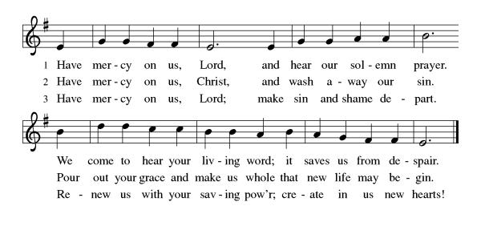**Kyrie** ELW (red) Setting 10, pg. 203

**Prayer of the Day**

The Lord be with you.

**And also with you.**

God of compassion, you welcome the wayward, and you embrace us all with your mercy. By our baptism clothe us with garments of your grace, and feed us at the table of your love, through Jesus Christ, our Savior and Lord, who lives and reigns with you and the Holy Spirit, one God, now and forever.

**Amen.**

*(Sit)*

**+++WORD+++**

**First reading:  Joshua 5:9-12**

9 The Lord said to Joshua, “Today I have rolled away from you the disgrace of Egypt.” And so that place is called Gilgal to this day.  
  10 While the Israelites were camped in Gilgal they kept the passover in the evening on the fourteenth day of the month in the plains of Jericho. 11 On the day after the passover, on that very day, they ate the produce of the land, unleavened cakes and parched grain. 12 The manna ceased on the day they ate the produce of the land, and the Israelites no longer had manna; they ate the crops of the land of Canaan that year.

Word of God, word of life.

**Thanks be to God.**

**Psalm****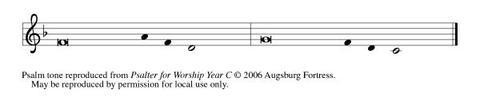 32**

1 Happy are they whose transgressions **|** are forgiven,  
  and whose sin is **|** put away!  
 2 **Happy are they to whom the Lord im- | putes no guilt,**  
  **and in whose spirit there | is no guile!**  
 3 While I held my tongue, my bones with- **|** ered away,  
  because of my groaning **|** all day long.  
 4 **For your hand was heavy upon me | day and night;**  
  **my moisture was dried up as in the | heat of summer.**  
 5 Then I acknowledged my sin to you, and did not con- **|** ceal my

guilt.  
  I said, “I will confess my transgressions to the Lord.” Then

you forgave me the guilt **|** of my sin.  
 6 **Therefore all the faithful will make their prayers to you**

**in | time of trouble;**  
  **when the great waters overflow, they | shall not reach**

**them.**  
 7 You are my hiding-place; you preserve **|** me from trouble;  
  you surround me with shouts **|** of deliverance.  
 8 **“I will instruct you and teach you in the way that | you**

**should go;**  
  **I will guide you | with my eye.**  
 9 Do not be like horse or mule, which have no **|** understanding;  
  who must be fitted with bit and bridle, or else they will **|** not

stay near you.”  
 10 **Great are the tribulations | of the wicked;**  
  **but mercy embraces those who trust | in the Lord.**  
 11 Be glad, you righteous, and rejoice **|** in the Lord;  
  shout for joy, all who are **|** true of heart.

**Second Reading: 2 Corinthians 5:16-21**

16 From now on, therefore, we regard no one from a human point of view; even though we once knew Christ from a human point of view, we know him no longer in that way. 17 So if anyone is in Christ, there is a new creation: everything old has passed away; see, everything has become new! 18 All this is from God, who reconciled us to himself through Christ, and has given us the ministry of reconciliation; 19 that is, in Christ God was reconciling the world to himself, not counting their trespasses against them, and entrusting the message of reconciliation to us. 20 So we are ambassadors for Christ, since God is making his appeal through us; we entreat you on behalf of Christ, be reconciled to God. 21 For our sake he made him to be sin who knew no sin, so that in him we might become the righteousness of God.

Word of God, word of life.

**Thanks be to God.**

*(Stand)*

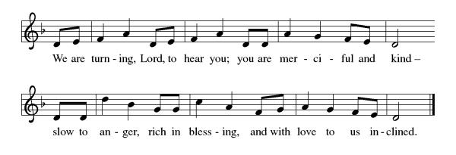**Lenten Acclamation ELW (red), Setting 10, pg. 205**

**Gospel:  Luke 15:1-3, 11b-32**

The holy gospel according to Luke.

**Glory to you, O Lord.**

1 Now all the tax collectors and sinners were coming near to listen to [Jesus.] 2 And the Pharisees and the scribes were grumbling and saying, “This fellow welcomes sinners and eats with them.”  
  3 So he told them this parable: 11b “There was a man who had two sons. 12 The younger of them said to his father, ‘Father, give me the share of the property that will belong to me.’ So he divided his property between them. 13 A few days later the younger son gathered all he had and traveled to a distant country, and there he squandered his property in dissolute living. 14 When he had spent everything, a severe famine took place throughout that country, and he began to be in need. 15 So he went and hired himself out to one of the citizens of that country, who sent him to his fields to feed the pigs. 16 He would gladly have filled himself with the pods that the pigs were eating; and no one gave him anything. 17 But when he came to himself he said, ‘How many of my father’s hired hands have bread enough and to spare, but here I am dying of hunger! 18 I will get up and go to my father, and I will say to him, “Father, I have sinned against heaven and before you; 19 I am no longer worthy to be called your son; treat me like one of your hired hands.” ’ 20 So he set off and went to his father. But while he was still far off, his father saw him and was filled with compassion; he ran and put his arms around him and kissed him. 21 Then the son said to him, ‘Father, I have sinned against heaven and before you; I am no longer worthy to be called your son.’ 22 But the father said to his slaves, ‘Quickly, bring out a robe—the best one—and put it on him; put a ring on his finger and sandals on his feet. 23 And get the fatted calf and kill it, and let us eat and celebrate; 24 for this son of mine was dead and is alive again; he was lost and is found!’ And they began to celebrate.  
  25 “Now his elder son was in the field; and when he came and approached the house, he heard music and dancing. 26 He called one of the slaves and asked what was going on. 27 He replied, ‘Your brother has come, and your father has killed the fatted calf, because he has got him back safe and sound.’ 28 Then he became angry and refused to go in. His father came out and began to plead with him. 29 But he answered his father, ‘Listen! For all these years I have been working like a slave for you, and I have never disobeyed your command; yet you have never given me even a young goat so that I might celebrate with my friends. 30 But when this son of yours came back, who has devoured your property with prostitutes, you killed the fatted calf for him!’ 31 Then the father said to him, ‘Son, you are always with me, and all that is mine is yours. 32 But we had to celebrate and rejoice, because this brother of yours was dead and has come to life; he was lost and has been found.’ ”

The gospel of the Lord.

**Praise to you, O Christ.**

*(Sit)*

**Children’s Message**

**Sermon** Rev. Dr. Carrie Carnes

*(Stand)*

**Hymn of the Day**, ELW (red) #606……………….… “Our Father, We

Have Wandered”

**Apostle’s Creed**

**I believe in God, the Father almighty,**

**creator of heaven and earth.**

**I believe in Jesus Christ, God’s only Son, our Lord,**

**who was conceived by the Holy Spirit,**

**born of the virgin Mary,**

**suffered under Pontius Pilate,**

**was crucified, died, and was buried;**

**he descended to the dead.\***

**On the third day he rose again;**

**he ascended into heaven,**

**he is seated at the right hand of the Father,**

**and he will come to judge the living and the dead.**

**I believe in the Holy Spirit,**

**the holy catholic church,**

**the communion of saints,**

**the forgiveness of sins,**

**the resurrection of the body,**

**and the life everlasting. Amen.**

*(Sit)*

**Installation of Council Members**

The following people have been *elected* by the congregation to positions of leadership. We give thanks for their willingness to serve. In baptism we are welcomed into the body of Christ and sent to share in the mission of God; we rejoice now that these *siblings* will lead us in our common life and our mutual mission as a congregation.

*A reading from First Corinthians:* There are varieties of gifts, but the same Spirit; and there are varieties of services, but the same Lord; and there are varieties of activities, but it is the same God who activates all of them in everyone. To each is given the manifestation of the Spirit for the common good. *(1 Corinthians 12:4-7)*

You have been *elected* to positions of leadership and trust in this congregation.

You are to see that the words and deeds of this household of faith bear witness to God, who gathers us into one together with the whole church.

You are to seek to involve all members of this congregation in worship, learning, witness, service, and support, so that the mission of Christ is carried out in this congregation, in the wider church, in this community, and in the whole world.

You are to be faithful in your specific area of serving, that the Spirit who empowers you may be glorified.

You are to be examples of faith active in love, fostering peace, harmony, and mutual understanding in this congregation.

On behalf of your sisters and brothers in Christ, I ask you:

Will you accept and faithfully carry out the duties of the offices

to which you have been *elected*?

*Response:* I will, and I ask God to help me.

*The assembly stands. Those being installed face the assembly.*

People of God, I ask you:

Will you support these, your *elected* leaders,

and will you share in the mutual ministry

that Christ has given to all who are baptized?

**We will, and we ask God to help us.**

I now declare you installed as council membersof this congregation.

Almighty God bless you, and direct your days and your deeds in peace,

that you may be faithful servants of Christ.

**Amen.**

**Prayers of Intercession**

Led by the Spirit, let us turn to God in prayer for the church, the world, and all those in need.

*A brief silence.*

God of faithful promise, make your church a new creation in Christ. As you reconcile us to yourself, guide us also in your way of reconciliation, that through confession and forgiveness, repentance and reparations, your church may bear witness to your love. God, in your mercy,

**receive our prayer.**

God of new beginnings, restore balance to the earth. Send rain to places of drought and sunshine to places of flooding, that the produce of the land may again support life. God, in your mercy,

**receive our prayer.**

God of prodigal grace, unite the nations as fellow members of the human family. Give leaders the courage to put aside pride and ego, to cease squandering lives and time, and to work for the well-being of all. God, in your mercy,

**receive our prayer.**

God of boundless love, receive with open arms any in need of compassion, especially Terry, Robert, Rose, Gaye, Dorothy, Harold, Brenda, Juan, Marsha, and Jim. Embrace all who are far from home or estranged from loved ones, and all who live with regret. Embolden your people to offer and to seek forgiveness. God, in your mercy,

**receive our prayer.**

God of radical inclusion, widen human circles to welcome all who are excluded. Bless the work of disability ministries, ministries by and with neurodivergent people, and multicultural and ethnic-specific ministries; that the welcome of Jesus be extended to all. God, in your mercy,

**receive our prayer.**

God of resurrection life, welcome home all who have died, especially Alan. We thank you for their lives and entrust them into your keeping, where true reconciliation and eternal peace are found. God, in your mercy,

**receive our prayer.**

We offer to you these prayers as well as those we now name to you either aloud or in our hearts.

Receive the prayers of your people and draw all things together in your love, in the name of Jesus, who leads us from death to life.

**Amen.**

**Peace**

The peace of Christ be with you always.

**And also with you.**

(*you may offer each other a sign of peace*)

**+++MEAL+++**

**Offering Music** “Our Father, We Have Wandered” Michael Burkhardt

*(Stand)*

**Offering Prayer**

Gracious Provider,

you set your immense treasures among us,

opening your heart to the world.

As we prepare to feast on your bountiful love,

deepen our commitment to sharing those

treasures with others,

through our Savior, Jesus Christ.

**Amen.**

**Great Thanksgiving**

The Lord be with you

**And also with you**

Lift up your hearts

**We lift them to the Lord**

Let us give our thanks to the Lord our God

**It is right to give our thanks and praise**

It is indeed right, our duty and our joy,

that we should at all times and in all places

give thanks and praise to you, almighty and merciful God,

through our Savior Jesus Christ.

You call your people to cleanse their hearts

and prepare with joy for the paschal feast,

that, renewed in the gift of baptism,

we may come to the fullness of your grace.

And so, with all the choirs of angels,

with the church on earth and the hosts of heaven,

we praise your name and join their unending hymn:

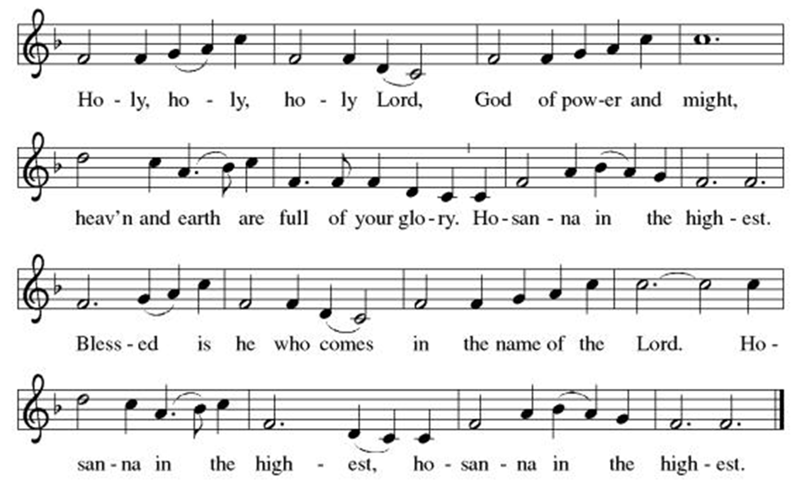**Holy, Holy, Holy ELW (red), Setting 10, pg. 207**

Holy God,

our living Water and our merciful Guide,

together with rivers and seas, wells and springs

we bless and magnify you.

You led your people Israel through the desert,

and provided them water from the rock.

We praise you for Christ, our Rock and our Water,

who joined us in our desert,

pouring out his life for the world.

In the night in which he was betrayed,

our Lord Jesus took bread, and gave thanks;

broke it, and gave it to his disciples, saying:

Take and eat; this is my body, given for you.

Do this for the remembrance of me.

Again, after supper, he took the cup, gave thanks,

and gave it for all to drink, saying:

This cup is the new covenant in my blood,

shed for you and for all people for the forgiveness of sin.

Do this for the remembrance of me.

Remembering, therefore,

his life, death, and resurrection,

we await your salvation for all this thirsty world.

Pour out your Spirit on this holy food

and on all gathered for this feast:

wash away our sin,

that we may be revived for our journey by the love of Christ.

Through him all glory and honor is yours,

Almighty Father, with the Holy Spirit,

in your holy Church,

both now and forever.

**Amen**

**The Lord’s Prayer**

**Our Father in heaven,** **hallowed be your name,**

**your kingdom come,** **your will be done,** **on earth as in heaven.** **Give us today our daily bread.** **Forgive us our sins**

**as we forgive those** **who sin against us.** **Save us from the time of trial** **and deliver us from evil.** **For the kingdom, the power,** **and the glory are yours,** **now and forever. Amen.**

**Invitation to Communion**

All who are hungry, come!

The feast of grace is spread.

*All are welcome to receive communion at Trinity Lutheran Church. If you wish to receive you may come forward as dismissed by the usher and will be given a wafer in the center aisle. Then you may take a small cup from the tray. Red wine is along the outside, and white grape juice is located in the center of the tray. Gluten free bread is also available. Place empty cups in the bowls located at the side aisle as you return to your pew. If you prefer to receive a blessing rather than communion, you may indicate that by crossing your arms over your chest as you come forward.*

*(Sit)*

**Distribution of Communion**

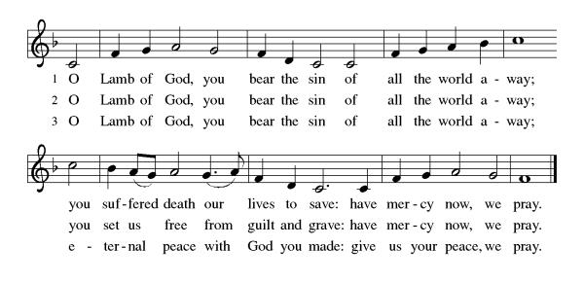Lamb of God ELW (red), Setting 10, pg. 208

*Communion Music “Our Father, We Have Wandered” David Maxwell*

**Post Communion Hymn** ELW (red) #460………..“Now in the Silence”

*(Stand)*

**Prayer After Communion**

Generous Host,

you have shared your feast with us and made us new.

Send us now to set tables of love and grace in our communities,

that your liberating love might nourish the world into freedom,

in the name of the crucified one, Jesus Christ our Lord.

**Amen.**

**+++SENDING+++**

**Blessing**

God our tender parent,

God the crucified one,

God the reconciling Spirit,

☩ bless you now and forever.

**Amen.**

**Sending Hymn** ELW (red) #763……………………. “My Life Flows On

in Endless Song”

**Dismissal**

Go in peace. Care for others as God cares for you.

**Thanks be to God.**

**Postlude**……….”Our Father, We Have Wandered”…..Johann Walther

From Sundays and Seasons.com. Copyright 2025. Augsburg Fortress. All rights reserved. Reprinted by permission under Augsburg Fortress Liturgies Annual License #23928. New Revised Standard Version Bible, copyright 1989, Division of Christian Education of the National Council of the Churches of Christ in the United States of America. Used by permission. All rights reserved.

***As you leave, please take a moment to greet one another.***

**Today’s radio broadcast was sponsored by** Tom & Marcy Simkins

*In honor of Trinity staff, past and present*

**Worship Participants**

Audio: Hillary Hoffman

Video: Sarah Brakenbury

Ushers: Cecilia & Lucia Crawford, Brian Robinson

Communion Setup: Jennifer Robinson

Assisting Minister: Isaac Triplett

Reader: Mark Holmes

Wine Servers: Bill Sime, Jennifer Holmes

Coffee Fellowship: John & Lynn Armstrong

Acolyte: Noah Crawford

Closing Duties: Hillary Hoffman

Pastor: Rev. Dr. Carrie Carnes

Organist: Bette Mohr

**Announcements**

**Coffee Fellowship** is immediately after service

**Holy Week is fast approaching!**

Community Holy Week Services will be at 12 Noon Monday April 14 -Thursday April 17 with Good Friday Services starting on the half hour 12-3pm on April 18th

**We will be celebrating Maundy Thursday at 1st Presbyterian Church at 7pm on April 17**. This is a combined service with Rev. Carrie Carnes preaching and Rev. Scott Carnes presiding at communion. Handwashing will be offered for those who wish.

**5:00 PM Saturday, April 19th we will be celebrating Easter Vigil** with Grace Episcopalian Church. Fr. Christopher Poore will preach and Rev. Carrie Carnes will preside at communion. This is a wonderful service, deeply rooted in tradition and should last about an hour.

**We are collecting donations for College Care Packages**

We have five students away at school who have more than earned some treats and encouragement. Care packages will be assembled at Trinity and then shipped out. All are welcome to donate the following:

* individually packaged food/snack items
* A short note/card of inspiration & encouragement. Cards are available in the narthex, and all are welcome to sign one and leave it in the labelled basket.

|  |  |  |  |
| --- | --- | --- | --- |
| **Prayer List:** If you or loved ones need prayers, please fill out the salmon-colored form located on the bulletin table in the Narthex, and return it to the Office mailbox or drop it in the offering plate. | | | |
| **Name** | | **Prayer** | |
| Jim Musolf | | Prayers for comfort | |
| Juan & Marsha Medina | | Prayers for comfort | |
| Terry | | Prayers for peace & strength | |
| Robert Sherman | | Prayers for healing & recovery | |
| Rose | | Prayers for strength & healing | |
| Gaye Burek | | Prayers for healing, strength, and peace | |
| Harold & Dorothy Ziehr | | Prayers for healing & strength | |
| Brenda Patterson | | Prayers for healing | |
| **This Week at Trinity** | | | |
| Sun, Mar 30th | 10:30 am | | Coffee Fellowship |
|  | 10:45 am | | Sunday School |
|  | 5:30 – 7:00 pm | | PRISMS |
| Tue, Apr. 1st | 6:00 pm | | Exec. Meeting |
| Wed., April 2nd | 6:30 pm | | Choir practice |
| Sat, April 5th | 5:00 pm | | **TLC** evening service |

Rev. Dr. Carrie Carnes, Pastor, Out-of-office: Friday

Cell phone: 618-803-8778

Church Office: Phone 309-343-4191

Hours 8:30 am – 12:30 pm, Monday-Friday

1st & 3rd Saturdays; Worship 5:00 pm; Holy Communion

Sunday Worship at 9:30 am; Holy Communion

Sunday Radio Ministry at 9:30 am on WRAM – 1330 AM, Facebook

[trinitylutheran@trinitygalesburg.org](mailto:trinitylutheran@trinitygalesburg.org)

mittee and Worship Committee. Finance committee will not meet. Childcare provided for children of committee members.

**Vision Statement**

**Developing Disciples – Connecting to Christ**

**Mission Statement**

**Led by the Spirit, we receive Christ’s love, share God’s forgiving grace, and reach out to welcome, encourage and serve all.**

**Welcome Statement**

At Trinity Lutheran Church, we believe God’s grace is extended to everyone. Members of Trinity Lutheran Church are freed by the Gospel to seek reconciliation and wholeness. We welcome people of all sexual orientations, gender identities, and gender expressions, whether believer, doubter, or seeker. In Christ's love we invite you, so that led by the power of the Holy Spirit we will join together to strive for racial equity, justice, peace, and love in all the earth.

**Our Guiding Principles**

1. Jesus Christ is Lord and Savior.

2. We faithfully worship through Word and Sacrament.

3. We invite and welcome everyone.

4. We engage all generations in education and ministry.

5. We serve local and global communities.